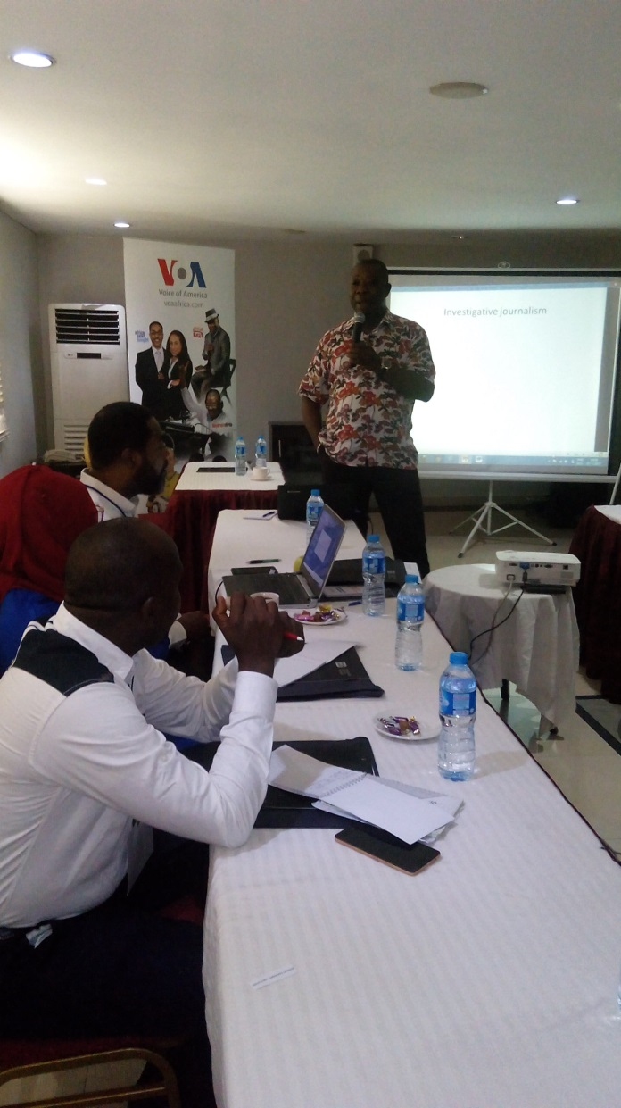
Trainer Anselm Okolo leads a session on Day 1

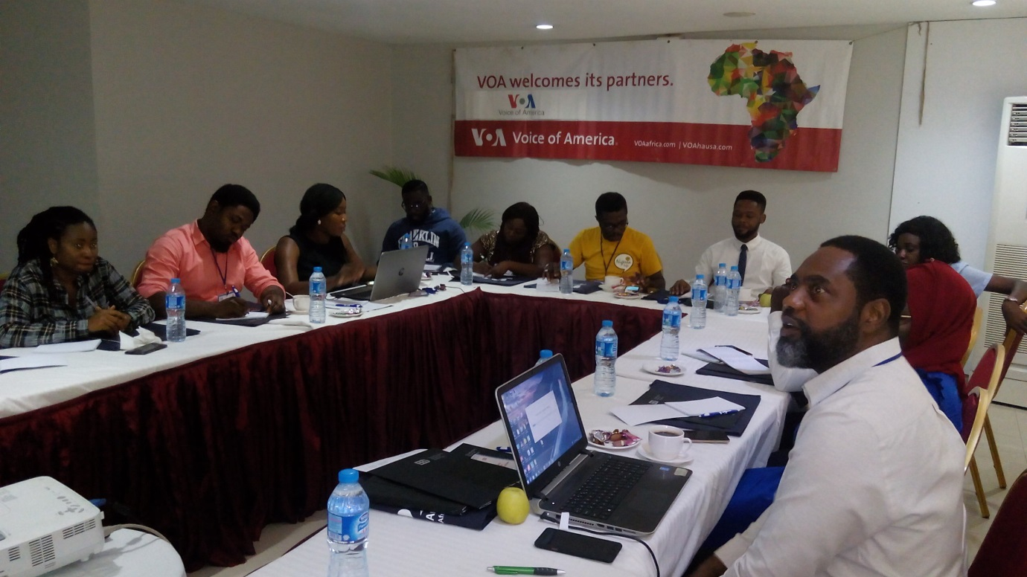
A cross section of participants at the training

By the end of the training:
- Trainees learnt and practiced writing in short sentences applying the principle of one idea by sentence.
- Trainees developed the outline of the story idea they identified as part of the training.
- Trainees worked in three groups to conduct interviews and write a story on a story idea of their choice.
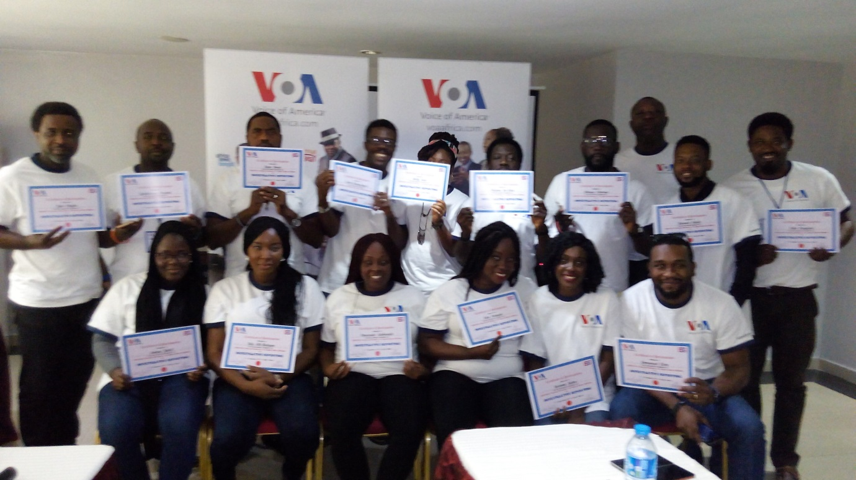

Participants were awarded certificates of participation at the end of the training.
However, majority of the participants still need help on basic reporting tricks, writing and sound collection techniques. This indicates that future trainings should include site visits for actual demonstration by the trainer and practice by the trainees.

Participants said the training was very useful to them. Some described it as an eye opener in scriptwriting, others said it was for them on interviewing while some others said the high point for them was the session on practical interviewing and writing sessions.

