

CONFLICT SENSITIVE REPORTING
AND ETHICS

LEARNER MODULE

This manual belongs:
Date of attendance :

Table of Contents
1.0 Introduction 3
MODULE 1.0 UNDERSTANDING CONFLICT 8
1.1 Is conflict violence? 8
1.3 Types of conflict 9
1.4 Characteristics of Conflict: 11
1.5 Journalism and the Stages in a conflict 12
2.7 Importance of understanding conflict 15
2.0 Module 2: Conflict sensitive reporting 16
2.1 Introduction to conflict sensitive reporting 16
2.1.1 The Media: The Good, the Bad, the Ugly 16
2.2 Why Professional and Ethical media coverage of conflict? 17
3.3 Conflict Analysis: What lenses can we view conflict with as journalists? 18
2.4 What are the inadequacies and inconsistencies in media reporting of conflicts? 19
2.5 Conflict analysis tools 20
Present scenarios: Conflict in Ethiopia and analyses tools 20
2.6 Characteristics of conflict that necessitates conflict analysis 23
2.7 Seven Tough questions that Journalists need to ask before covering conflict situations 23
2.8 What is Conflict Analysis 24
2.9 Conflict Analysis and its aim towards conflict sensitive reporting 25
2.10 Understanding conflict Dimensions for wholesome reporting 25
2.11 Methods of conflict analysis 25
2.12 Phases of Conflict in the Conflict Circle: 26
2.12 Conflict dynamics 26
2.14 Analysing the Actors 27
2.15 Key issues to consider when undertaking conflict analysis 27
2.16 Conflict Mapping 28
2.17.1 Timeline tool 29
2.17. 2 Conflict Onion 30
2.17.2 The ABC Triangle 31
2.17.3 The Conflict Triangle 33
2.17.3 Conflict Tree 33
2.17.4 The Iceberg Model 35
2.18 Dos and Don'ts in Conflict and Peace Building 35
2.19 Some practical tips for conflict reporting 36
2.20 Components of stories with good background of conflict analysis 38
3.0 Module three Ethics in Reporting Conflict 41
3.1 Interviewing people affected by conflict 41
3.2 Some general tips for conflict sensitive interviewing 41
3.3 Interviewing people affected by conflict 42
3.4 Media conflict and Gender 43
Group work: Discuss the role and impact of conflict on women. 43
3.4.1 Why Conflict is Gendered? 43
3.4.2 Trends in Reporting on Gender and Conflict 44
3.5 Personal safety of journalists 45
3.6 Personal safety tips 46
3.7 Amplifying conflict sensitive reporting voices 46
References 48

1.0 Introduction

1.1 Course outcomes

This three-day course is specially designed to provide journalists with an understanding of conflict and how it undermines development and democracy in any nation. The course is meant to create awareness that will lead to more objective reporting that is devoid of fanning the flames of conflict. The course will explore what is conflict, the sources of conflict, stages, effects, the role of the media, conflict analysis tools, gender and conflict reporting and strategies of conflict sensitive reporting.

At the conclusion of this training, journalists will:

- Have a clear understanding of the sources of conflict in Ethiopia, Africa and globally
- Have a broad overview of the role of the media in conflict transformation
- Understand how they can apply conflict sensitive reporting techniques to improve reporting and connect better with their audiences.
- Understand the ethical implications of conflict sensitive reporting.
- Be able to pursue their own conflict transformation stories.

1.2 Grounds to be covered

THEME ONE: CONFLICT

1. Understanding conflict
- Defining Conflict
- Group exercise: What is the state of conflict in your country?
3. Characteristics of conflict
Discussion: What are the characteristics of conflict in your country?
4. Understanding the stages of conflict

- How does conflict begin?
- What are the stages
- Distinction between conflict and violence

5 Types of conflict
- Discussion: Types of conflict in your country
6. Effects of conflict on development
- Discussion: How has conflict affected your country
- Video: Conflict in Ethiopia
- Presentation: Effects of conflict on development

7. Role of the media in conflict development and transformation
- What role can the media play in conflict?
- Group exercise: What can the media do in conflict situations

THEME TWO: Conflict sensitive reporting

1. Conflict sensitive reporting
- What is conflict sensitive reporting
- Why conflict sensitive reporting
- Concepts of CSR

2. Tools of Conflict Analysis
- Discussion: What are the various approaches employed to forestall conflict?
- Presentation: Conflict Analysis Tools
- Group exercise: Let’s take one conflict and analyse it

3. Do's and Don'ts of conflict sensitive reporting
- Individual exercise: Create own do's and don'ts in conflict sensitive reporting

4. Checklist for conflict sensitive reporting
- Group exercise: Create your own checklist for CSR

THEME THREE: Conflict sensitive reporting and ethics

1. Strategies for conflict sensitive reporting
- How conflict reporting is changing globally
- Group exercise: collaborations
2. Dealing with victims of conflict
Discussion: Does it matter?
To what extent?

3. Lenses of gender during conflict
Reporting women and conflict

4. Personal safety in conflict situation
How secure should one be
3. Amplifying voices on conflict
Using new media avenues to tell conflict stories.


CONFLICT REPORTING AND ETHICS

DATES: 30 JULY -1ST AUGUST 2019
CANDIDATES: This course is specially designed for journalists affiliated to Voice of America who want to deepen their understanding of conflict sensitive reporting and ethics in Ethiopia. It will cover such questions as:
- What is conflict?
- What is the state of conflict in Ethiopia?
- What are the stages of conflict
- What are the effects of conflict on development
- What is the role of the media in conflict development and transformation
- What is conflict sensitive reporting
- What are conflict analysis tools
- What are the Dos and don'ts in conflict sensitive reporting
- Checklist for conflict sensitive reporting
- What are the strategies for conflict sensitive reporting
- How do you deal with victims of conflict
- How do you ensure safety in a conflict situation

FACILITATOR: AYUB MWANGI

DAY 1
Time
01:00 – 01:30 |  | Registration, introductions and expectations
01:30 – 2:30 |  | What is conflict?
2:30 - 4:00 |  | State of conflict in Ethiopia (Practical Workshop)
4:00 – 4:15 |  | Comfort / Tea Break
4.15 – 6:00 |  | Characteristics and types of conflict
6:00 – 7:00 |  | DINNER/SUPPER
7:00 – 8:00 |  | Understanding the stages of conflict
8:00 – 8:15 |  | Comfort / Tea Break
8:15 - 9:00 |  | Effects of conflict on development
DAY 2
Time
01:00 – 01:30 |  | Introduction to conflict sensitive reporting  Role of the media in conflict development and transformation
01:30 – 2:30 |  | Conflict analysis tools
2:30 - 4:00 |  | - Gap analysis and context-building  - Using the Timeline Tool  - ABC Triangle
4:00 – 4:15 |  | Comfort / Tea Break
4.15 – 6:00 |  | - The conflict triangle  - Conflict tree  - Iceberg model
6:00 – 7:00 |  | DINNER/SUPPER
7:00 – 8:00 |  | What are the Dos and don'ts in conflict sensitive reporting
8:00 – 8:15 |  | Comfort / Tea Break
8.15-9.00 |  | Checklist for conflict sensitive reporting

DAY 3
Time |  | Subject Area
01:00 – 2.00 |  | Strategies for conflict sensitive reporting
2.00- 3.30 |  | Dealing with victims of conflict
2:30 - 4:00 |  | Lenses on gender situations during armed conflict
4:00 – 4:15 |  | Comfort / Tea Break
4.15 – 6:00 |  | Personal safety in a conflict situation
6:00 – 7:00 |  | Dinner/supper
7:00 – 8:00 |  | Amplifying conflict sensitive reporting voices
8:00 – 8:15 |  | Comfort / Tea Break
8.15-9.00 |  | Workshop evaluations , graduation and awarding of certificates and closing

MODULE 1.0 UNDERSTANDING CONFLICT

1. Understanding conflict
- Defining Conflict
- Mind Mapping: What is your personal understanding of conflict?
- Discussion: Conflict exists in both a societal and interpersonal level

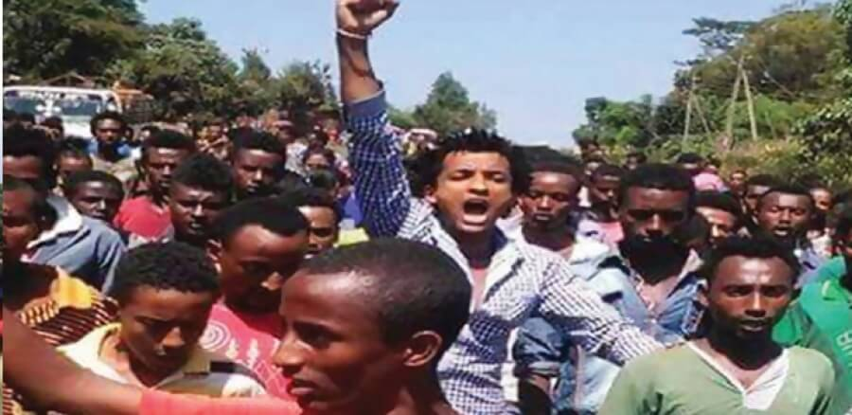
Conflict can be defined in different ways. When speaking of conflict, what immediately comes into mind would be how differences and disagreements make such an occurrence to spring up. Conflict can therefore be described as
- A disagreement among groups or individuals characterized by antagonism and hostility. This is usually fueled by the opposition of one party to another, in an attempt to reach an objective different from that of the other party. The elements involved in the conflict have varied sets of principles and values, thus allowing such a conflict to arise.
- A situation where two or more individuals or groups try to pursue goals or ambitions which they believe they cannot share (Howard 2004)
- Conflict, in the context of Conflict-Sensitive Journalism, has been defined by Deutsch and Coleman as a situation where two or more people have or think they have incompatible goals and undermine each other’s goal-seeking potential (as cited by Byrne & Senehi, 2009, p. 3).
- Conflict exists in a relationship when parties believe their aspirations cannot be achieved at the same time, or perceive a divergence in their values, needs or interests (latent) and purposefully mobilise the power that is available to them in an effort to eliminate, neutralise, or change each other to protect or further their interests in the interaction (manifest conflict) (Anstey, 2008.)

Group exercise: What is the state of conflict in your country?

1.1 Is conflict violence?
Not all conflict is violent. Conflict is normal when there is change. Some people want change, but others disagree. If their disagreement or their conflict is managed peacefully, it can be a positive process. But when conflict is not managed properly, it becomes violent. In violent conflict, people fear for their safety and survival. When we say conflict, we are usually referring to violent conflict.
Conflict is not synonymous with violence. Conflict is normal and is an agent of change, as posited by Pearson and Lounsbery (2009): Scholars and practitioners of conflict resolution tend to recognize that not all forms of conflict can be considered negative interaction (Rothman and Olson, 2001). Conflict can be quite constructive in stimulating inter-party communication and problem-solving in a collaborative manner. (p. 72). Violence, on the other hand, is a strategy characterized by the use of force, employed to resolve conflict. Violence, therefore, is the product of choice. Sometimes, it is the result of official policy of the state and the values it propagates.

1.2 Sources of Conflict:

Group discussion: What are the sources of and types conflict in Ethiopia?

Almost world-wide, it is predictable that conflict will arise where:
- Resources are scarce and not shared fairly, as in food, housing, jobs or land.
- There is little or no communication between the two groups.
- The groups have incorrect ideas and beliefs about each other.
- Unresolved grievances exist from the past.
- Power is unevenly distributed.

Early reviews in the field of conflict resolution identified a large number of schemes for describing sources or types of conflict (Fink, 1968; Mack & Snyder, 1958). One of the early theorists on conflict, Daniel Katz (1965), created a typology that distinguishes three main sources of conflict: economic, value, and power.

Economic conflict involves competing motives to attain scarce resources. Each party wants to get the most that it can, and the behavior and emotions of each party are directed toward maximizing its gain. Union and management conflict often has as one of its sources the incompatible goals of how to slice up the “economic pie”.
2. Value conflict involves incompatibility in ways of life, ideologies – the preferences, principles and practices that people believe in. International conflict (e.g., the Cold War) often has a strong value component, wherein each side asserts the rightness and superiority of its way of life and its political-economic system.
3. Power conflict occurs when each party wishes to maintain or maximize the amount of influence that it exerts in the relationship and the social setting. It is impossible for one party to be stronger without the other being weaker, at least in terms of direct influence over each other. Thus, a power struggle ensues which usually ends in a victory and defeat, or in a “stand-off” with a continuing state of tension. Power conflicts can occur between individuals, between groups or between nations, whenever one or both parties choose to take a power approach to the relationship. Power also enters into all conflict since the parties are attempting to control each other.

1.3 Types of conflict
When you think of the different types of conflict, you might instantly think of the ones referred to in literature, especially in fiction. They can be applied to real life, of course. However, there are types of conflict which are easily identifiable in our contemporary times.
Before going any further, let us first give a brief description of what conflict is. There are actually a lot of ways to define conflict due to how it is used in many areas. Hence, to keep it simple for the layman, conflict pertains to the opposing ideas and actions of different entities, thus resulting in an antagonistic state. Conflict is an inevitable part of life. Each of us possesses our own opinions, ideas and sets of beliefs. We have our own ways of looking at things and we act according to what we think is proper. Hence, we often find ourselves in conflict in different scenarios; may it involve other individuals, groups of people, or a struggle within our own selves. Consequently, conflict influences our actions and decisions in one way or another.
Conflict is classified into the following four types:
- Interpersonal conflict refers to a conflict between two individuals. This occurs typically due to how people are different from one another. We have varied personalities which usually results to incompatible choices and opinions. Apparently, it is a natural occurrence which can eventually help in personal growth or developing your relationships with others. In addition, coming up with adjustments is necessary for managing this type of conflict. However, when interpersonal conflict gets too destructive, calling in a mediator would help so as to have it resolved.
- Intrapersonal conflict occurs within an individual. The experience takes place in the person’s mind. Hence, it is a type of conflict that is psychological involving the individual’s thoughts, values, principles and emotions. Interpersonal conflict may come in different scales, from the simpler mundane ones like deciding whether or not to go organic for lunch to ones that can affect major decisions such as choosing a career path. Furthermore, this type of conflict can be quite difficult to handle if you find it hard to decipher your inner struggles. It leads to restlessness and uneasiness, or can even cause depression. In such occasions, it would be best to seek a way to let go of the anxiety through communicating with other people. Eventually, when you find yourself out of the situation, you can become more empowered as a person. Thus, the experience evoked a positive change which will help you in your own personal growth.
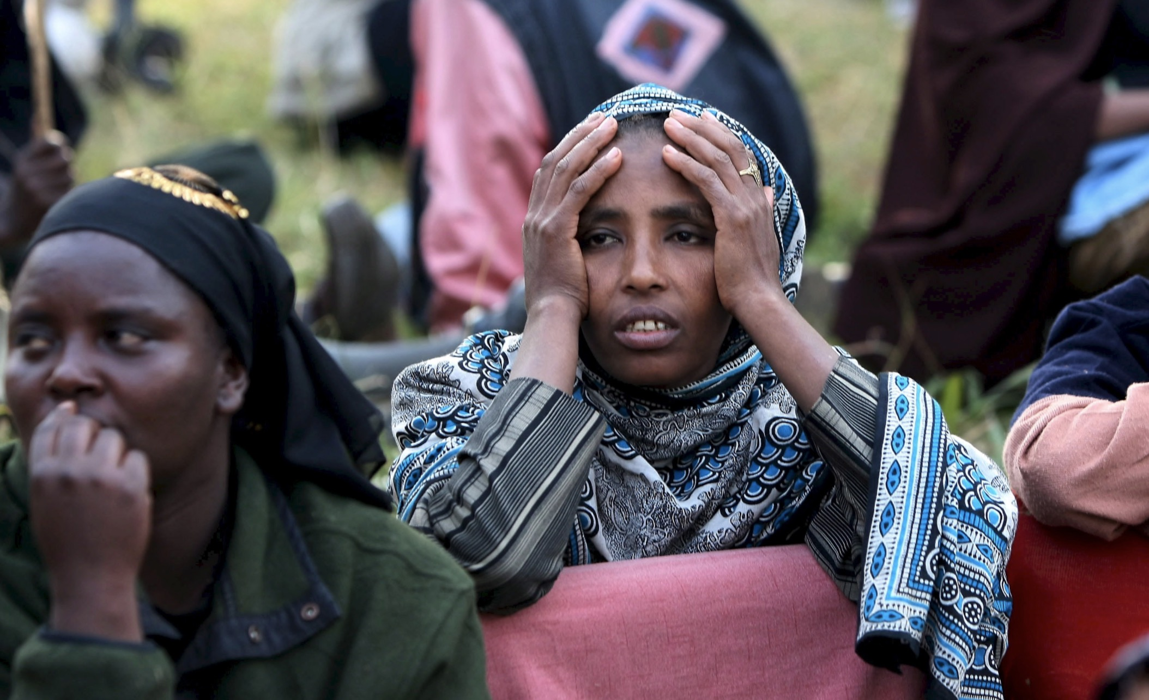
- Intragroup conflict is a type of conflict that happens among individuals within a team. The incompatibilities and misunderstandings among these individuals lead to an intragroup conflict. It is arises from interpersonal disagreements (e.g. team members have different personalities which may lead to tension) or differences in views and ideas (e.g. in a presentation, members of the team might find the notions presented by the one presiding to be erroneous due to their differences in opinion). Within a team, conflict can be helpful in coming up with decisions which will eventually allow them to reach their objectives as a team. However, if the degree of conflict disrupts harmony among the members, then some serious guidance from a different party will be needed for it to be settled.
- Intergroup conflict takes place when a misunderstanding arises among different teams within an organization. For instance, the sales department of an organization can come in conflict with the customer support department. This is due to the varied sets of goals and interests of these different groups. In addition, competition also contributes for intergroup conflict to arise. There are other factors which fuel this type of conflict. Some of these factors may include a rivalry in resources or the boundaries set by a group to others which establishes their own identity as a team.
- Conflict may seem to be a problem to some, but this isn’t how conflict should be perceived. On the other hand, it is an opportunity for growth and can be an effective means of opening up among groups or individuals. However, when conflict begins to draws back productivity and gives way to more conflicts, then conflict management would be needed to come up with a resolution.
- Conflicts can be categorized into groups for easier comprehension. Conflicts can be data or information related, relationship related, or structure and systems related. These factors may also be value related or interests related.

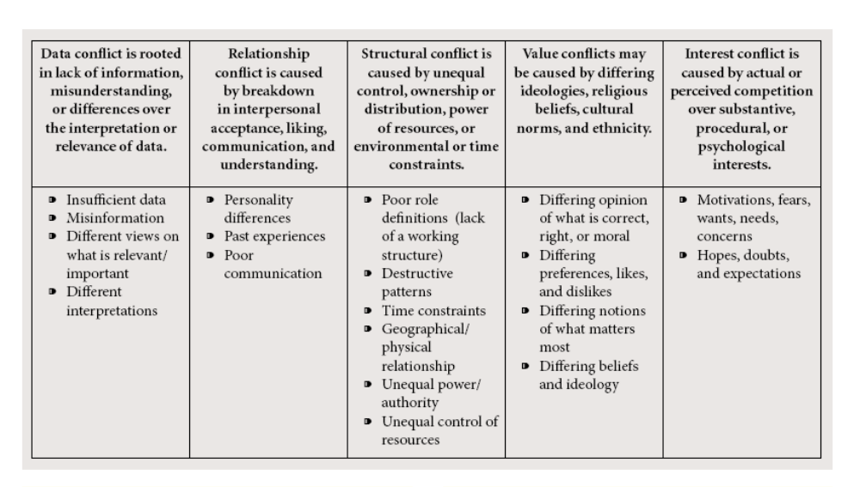

1.4 Characteristics of Conflict:

Plenary Discussion: What are the distinctive features of conflict in Ethiopia?

1. Conflict is a Process:
Conflict occurs in ‘layers’. First layer is always misunderstanding. The other layers are differences of values, differences of viewpoint, differences of interest, and interpersonal differences. It is also called a process because it begins with one party perceiving the other to oppose or negatively affect its interests and ends with competing, collaborating, compromising or avoiding.

2. Conflict is Inevitable:
Conflict exists everywhere. No two persons are the same. Hence they may have individual differences. And the differences may be because of values or otherwise, lead to conflict. Although inevitable, conflict can be minimized, diverted and/or resolved. Conflict develops because we are dealing with people’s lives, jobs, children, pride, self-concept, ego and sense of mission. Conflict is inevitable and often good, for example, good teams always go through a “form, storm, norm and perform” period.
3. Conflict is a Normal Part of Life:
Individuals, groups, and organizations have unlimited needs and different values but limited resources. Thus, this incompatibility is bound to lead to conflicts. The conflict is not a problem, but if it is poorly managed then it becomes a problem.
4. Perception:
It must be perceived by the parties to it, otherwise it does not exist. In interpersonal interaction, perception is more important than reality. What we perceive and think affects our behaviour, attitudes, and communication.
5. Opposition:
One party to the conflict must be perceiving or doing something the other party does not like or want.

6. Interdependence and Interaction:
There must be some kind of real or perceived interdependence. Without interdependence there can be no interaction. Conflict occurs only when some kind of interaction takes place.
7. Everyone is inflicted with Conflict:
Conflict may occur within an individual, between two or more individuals, groups or between organisations.
8. Conflict is not Unidimensional:
It comes into different ways in accordance with degree of seriousness and capacity. At times, it may improve even a difficult situation.

The Stages in a conflict and Journalism

There are five stages in a conflict. These are latent conflict, perceived conflict, felt conflict, manifest conflict, and conflict aftermath.

Stages of conflict development
This section concentrates on some of the different stages that conflicts go through as they escalate and begins to consider some of the different roles journalists might play in enabling parties to address conflicts constructively.

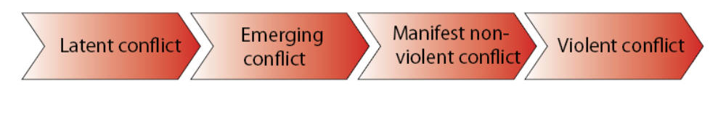

(i) Latent Conflict: The first stage of conflict is latent conflict in which the factors that could become a cause of potential conflict exist. These are the dry for autonomy, divergence of goals, role conflict and the competition for scarce resources.

Latent conflict occurs when conditions that have the potential to result in conflict exist, but have not yet been recognised by the parties involved. Latent conflict might be said to exist when a group decides to pursue a goal without recognising that this might be, or appear to be, incompatible with the goals of another group. The following are some examples of latent conflict:
• A group of farmers decides to set traps to stop predators stealing their sheep. In their minds the animals are vermin who are threatening their livelihoods. The farmers may be unaware that if they use the traps this might lead to conflicts developing between themselves and conservationists and animal rights activists.
• Women in particular societies have dressed conservatively for generations, always wearing long dresses. In time some of the women decide they want to follow more modern trends and begin wearing skirts, mini-skirts and tight jeans. In doing so they may be setting themselves up for confrontations with men who cling to traditional values.
• A minority group in a particular country decides that it no longer wishes to remain part of the country or province dominated by people from another group. The conflict can remain latent until people decide they want to take action. The moment the minority group begins making demands for a territory of its own the conflict begins to emerge.
• People living in a particular community may have been tolerant of poor service delivery for many years. However, when they observe that other communities are getting services and that they are being left behind their frustration can develop.
• There are gross inequalities of incomes across a society which stem from the way in which the society is structured. Attempts to bring about change through conventional channels such as elections and political processes are thwarted. Resentment over the inequalities grows and people start to mobilise to bring about change. There might be people who think that so long as a conflict remains latent, all is well. They may recognise that the conditions are there, but prefer to ignore them in the interests of keeping the peace. The problem with this approach is
that issues never get addressed. The reality is that unless something happens it’s unlikely that the concerns of all parties involved will be addressed. People can become increasingly frustrated and less tolerant of others without the conflict even having begun to really emerge. At times it can be important to identify latent conflicts and to make the issues visible so that they can be addressed.

(ii) Perceived conflict: Sometimes a conflict arises even if no latent conflict is present. In this stage one party perceived the others to be likely to thwart or frustrate his or her goals. The case, in which conflict is perceived when no latent conflict arises, is used to result from the parties misunderstanding each other’s true position. Such conflict can be resolved by improving communication between the groups.

Emerging conflict begins when groups perceive that they have mutually incompatible goals. It can also begin to emerge when a disadvantaged group decides that conditions are unjust and that they are no longer prepared to tolerate the status quo. In many cases groups have accepted the rule of dominant groups for lengthy periods, but as these communities became more conscious of their own exploitation they recognised the need for change. Conflict can emerge when one group starts to express the need for change, while the other makes it clear that they will resist change. At this stage it can be clear that parties acknowledge the existence of conflict and they may well have identified their opponents. They might have entered into negotiations and begun to signal that there is a need for change, while other groups might be making it equally clear that change will be resisted.

(iii) Felt Conflict: Felt conflict is the stage when the conflict is not only perceived but actually felt and cognized. For example, A may be aware that he is in serious argument with B over some policy. But this may not make. A tense or anxious and it may have no effect, whatsoever, on A’s affection towards B. The personalization of conflict is the mechanism which causes many people to be concerned with dysfunctions of conflict. In other words, it makes them feel the conflict. There are two reasons for the personalization of the conflict:
(i) the inconsistent demands on efficient organization and individual growth which is caused within the individual. Anxieties may also result from crisis or from extra-organizational pressures. Individuals need to vent these anxieties in order to maintain equilibrium.
(ii) Conflict becomes personalized when the whole personality of the individual is involved in the relationship. Hostile feelings are most common in the intimate relations that characterize various institutions and residential colleges.

(iv) Manifest Conflict: Manifest conflict is the stage when the two parties engage in behavior which evokes response from each other. The most obvious of these responses are open aggression, apathy, sabotage, withdrawal and perfect obedience to rules. Except for prison riots, political revolutions and extreme labor unrest, violence as a form of manifest conflict is rare. The motives towards violence may remain they tend to be expressed in less violent forms.

Non-violent conflict occurs when groups begin to mobilise their power in order to bring about change, while other groups prepare to resist it. This stage is often characterized by threats and attempts by parties to persuade others to see the conflict from their point of view and to persuade them to change their views. At the same time they will often try to mobilise as much support as possible. In doing so they will want to demonstrate that they are strong and that they have the capacity to either force the other to give in or will be able to resist any attempt to force them to capitulate. They will also try to convince outsiders that their cause is just, hoping external pressure will force opponents to relinquish their positions. This stage of conflict can include relatively benign attempts to persuade others to concede to the party’s demands. However, if the other parties refuse to make concessions or to capitulate, the initial party’s actions can shift from persuasion to threats.

(v) Conflict Aftermath: The aftermath of a conflict may have positive or negative repercussion for the organization depending upon the how conflict is resolved. If the conflict is genuinely resolved to the satisfaction of all participants, the basis for more cooperative relationship may be laid or the participants in their drive for a more ordered relationship may focus on latent conflicts not previously perceived and dealt with. On the other hand, if the conflict is merely suppressed but not resolved, the latent conditions of conflict may be aggravated and explode in a more serious from until they are rectified. This conflict episode is called conflict aftermath.

Actual violent conflict begins when parties start using physical force against one another. This can mark the beginning of an extremely destructive phase that introduces a mass of new dynamics into the conflict. Not only will parties need to ultimately find ways of addressing the issues that originally led to the conflict, but they will also have to find ways of reconciling people and communities that have lost loved ones or been harmed during the confrontation.
An important aspect here is the fact that the progression from one level to the next is generally marked by a triggering event — something that happens which can push parties to escalate the conflict. Once conflicts become manifest this can mark the start of a spiral of conflict. Conflict triggers can take on many forms and may even be only tangentially related to the conflict. For example, when tensions exist between different political groups living in an informal settlement a dispute over a stolen chicken can trigger a massive confrontation
between people from different factions.
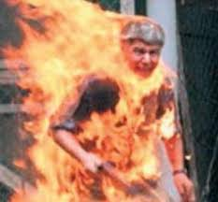
The excessive use of force by the police in controlling or preventing a demonstration has frequently served to trigger widespread violence when communities are demanding improved services. A dramatic example of a conflict trigger that had global ramifications was the death of Mohammed Bouazizi, a fruit vendor who set himself alight on 17 December 2010. Bouazizi’s protest against the confiscation of his wares and the harassment and humiliation he experienced at the hands of a municipal official sparked the uprising in Tunisia that marked the beginning of what has come to be known as the “Arab Spring” a revolutionary wave of demonstrations and protests that swept around countries in the Arab world including Egypt, Libya, Yemen, Bahrain, Syria, Algeria, Iraq, Jordan, Kuwait and Morocco. The source of the demonstrations is believed to have been widespread dissatisfaction with authoritarian leadership, poverty, unemployment, human rights violations and government corruption.

When it comes to reporting on conflict journalists tend to concentrate their coverage on the last two stages of conflict escalation, frequently ignoring the latent and emerging stages of a conflict. This focus on the moments of real action rather than on the overall process can have a number of negative implications. It can lead to audiences developing a distorted understanding of events. Instead of recognising that a conflict has welled up over time in response to a range of different issues, audiences can be left thinking the conflict flared without warning. Under these circumstances people will commonly blame those who seem to be the most belligerent without understanding that these people may have made repeated attempts to address issues without threats and violence. It can also mean that journalists miss out on opportunities to sound early warning signals about impending confrontations and this can mean people
miss out on chances to solve conflicts before they become destructive. Journalists will only be able to identify latent and emerging conflicts if they are spending time with communities and taking the time to learn about the things that are of concern. Journalists who stay in the newsroom and wait for things to happen will seldom pick up on conflicts until they reach the stages of actual confrontation.

2.7 Importance of understanding conflict


Denis McQuail (2000, 66) provides a list of mediation roles the media play, which can inform an understanding of the role of they play in peace building, including the following:

- Window on events and experience
- Mirror of events in society and the world
- Filter or gatekeeper
- Signpost, guide, or interpreter
- Forum or platform for the presentation of information and ideas
- Interlocutor or informed partner in conversation.

Beyond the roles identified by McQuail,
- the media can ease social conflicts and promote reconciliation (Coronel 2003; Hamelink 2008).
- They also provide warring factions mechanisms for mediation, representation, a voice, and platforms to settle differences peacefully.
- In conflict prevention and management they are information providers and interpreters, watchdogs and gatekeepers, policymakers and diplomats, and peace promoters and bridge builders (Bratic and Schirch 2007).

2.0 Module 2: Conflict sensitive reporting
Introduction to conflict sensitive reporting
Role of the media in conflict development and transformation
Conflict analysis tools
Gap analysis and context-building

- Conflict Onion
- ABC Triangle
- The violence triangle
- Multi party geometry

What are the Dos and don'ts in conflict sensitive reporting?
Checklist for conflict sensitive reporting

2.1 Introduction to conflict sensitive reporting

More insidious and intractable are the numerous protracted inter-ethnic and religious conflicts and low-level insurgencies that breed insecurity and instability in many communities, demanding more effective interventions from state and non-state actors alike.
The media constitute one of the key non-state actors whose work can contribute to peace building in the region, although the perception persists that they are often disruptive rather than helpful in promoting and sustaining peace. Indeed conflicts are partly what the media make them to be. Thus how journalists mediate information and debate on conflict influences perceptions of it and the peace building process.
Journalists have played ignoble roles in conflicts in Rwanda, Sierra Leone, Kenya, and Nigeria but have also been unsung heroes in some of these same conflicts and in countless others when they have reported on them sensitively and in a manner that helps bring about peace. Sorious Samura’s documentary Cry Freetown in 2000 is but one example of courageous journalism that can turn the tide in helping to bring about the end of war.

2.1.1 The Media: The Good, the Bad, the Ugly
The media as the “Fourth Estate” play a crucial role in building an accountable state and society, whether at the national or local level. They are a critical part of the triangular relationship between state, citizens, and information, which helps to ensure responsiveness of government to the people. Free media can act as an echo chamber for discontent within society as citizens express their priorities and concerns. Without this pressure valve, discontents are more likely to be expressed through explosive public protests or acts of violence.
The media also contribute to nation-building by disseminating information on laws, policy, service delivery programs, and priorities from the government and politicians to the people and by reporting on the opinions and reactions of the people to policies and issues (e.g., through letters to the editor). In many fragile and conflict-affected countries, the media have been harnessed by peacebuilding actors to disseminate messages and programming that promote peaceful coexistence and development, or raise awareness of solutions to divisive issues. Such media interventions may be in the form of newspaper advertisements or radio jingles on specific themes, such as reducing domestic violence, or constitute entire production and broadcasting networks devoted to peace-positive broadcasting. Often media programming can be syndicated, translated, or reproduced to provide cost-effective, attitude- and behavior-changing programming for local media on security issues. Radio listeners’ groups can also be useful to discuss, reinforce, and provide feedback on the impact of messages. In a nutshell, a free and independent media’s contribution to peacebuilding is the restoration of the free flow of information, opinions, and feedback.
In the best of times, journalism in Africa is a difficult way to earn a living. Even in relatively peaceful times, it can be a downright dangerous profession. In the traditional view of journalism, practitioners are expected to report events as neutrally and accurately as possible and not to take sides. But this orthodox view fails to accommodate reality: there is no dividing wall between African journalists and the sometimes cataclysmic events swirling around them that they attempt to make sense of in their reports. Consequently, they invariably get caught up in the eye of the storm (Onadipe 2001).
History has shown that the media can incite people toward violence as well as peace. The common assertion in America that “CNN took us to Somalia, CNN brought us out of Somalia” makes the point. It is also argued that Hitler used the media to create an entire worldview of hatred for Jews, homosexuals, and other minority groups. Rwanda’s radio RTLM urged listeners to pick up machetes and kill what they called “the cockroaches,” while broadcasters in the Balkans polarized local communities to the point where violence became an acceptable tool for addressing grievances.
The media mostly covers conflict, not peacebuilding. Its impact on the escalation of conflict is more widely recognized than its impact on peacebuilding. Yet it is not uncommon to hear experts say that the media’s impact on peacebuilding must be significant given its powerful influence on conflict. The common journalistic maxim that “If it bleeds, it leads” means violent conflicts make headline news, rather than cross-cultural dialogue and understanding. This tendency to cover conflict and violence distorts reality and leads many people to think that conflict is pervasive and peace is abnormal.
The media shape what we see and hear about conflict. Journalists’ opinions and beliefs are mostly based on their experiences in the field. Media owners have economic interests; they want to sell their stories and programs to a public who will buy their newspapers or watch their broadcasts. Increasing corporate control over media in some countries also plays a role in determining the type of stories that are covered and the way they are framed.

Conclusions
Society is shaped, reshaped, and unshaped by the media and this is why the media constitutes the good, the bad, and the ugly or what some scholars have termed the necessary evil. The media are key stakeholders in all the various pillars of peacebuilding. They can be reliable sources of information and provide channels for early warning signals to communities under threat. They also play a critical role in conflict data collation processes, are good data analysts, and through their interactions with communities, make informed analysis and judgments. Above all, good practice in conflict prevention includes having strong inter-linkages and effective communication channels between early warnings and response structures and the media is just the right vehicle for that.
It is therefore right to conclude that the media, whether electronic or print, private or public, wields enormous influence in peace and security.

2.2 Why Professional and Ethical media coverage of conflict?
Accurate, objective and reliable reporting of conflict by journalists is very important. It can assist in lessening the tension by bringing out facts, correcting misperceptions and presenting realities which would otherwise be ignored by conflicting parties.
Quality reporting of conflict helps avoid stereotypes and narrow perspectives on the causes and process of conflict. We need to appreciate that quality reporting cannot happen without clear understanding of conflict through conflict analysis.
The Media can explore and provide information about opportunities for resolution and also assist the parties into dialogue through accurate reporting of issues. This can only happen if journalists have a good understanding of conflict situation.
Journalists have a potential to contribute to conflict escalation, interfere with peace process, derail negotiations, misinform the public through inaccurate, insensitive and sensational reporting. Conflict analysis does not aim to shape or limit how journalist report on conflict situations. Objectively, it helps to create a broader, deeper and objective understanding of the conflict situation in a way that enhances quality reporting. Essentially, conflict analysis makes a journalist’s subjective perceptions transparent.

3.3 Conflict Analysis: What lenses can we view conflict with as journalists?
According to Du Toit (2010), conflict is a dynamic situation and changes depending on the level it is at each stage and this is precipitated by factors including entry of new actors. Conflict analysis usually involves an assessment of key conflict factors which include the sources of tension and root causes of conflict, including linkages and synergies. Conflict analysis also considers the actors including; interests, potential spoilers, capacities for violence and peace, incentives required to promote peace. Lastly, it looks at the dynamics; triggers for violence and likely future scenarios in terms of conflict resolution and peaceful co-existence.
Understanding conflict is very important because conflict is always about change. Among other things, it’s about people trying to meet unfulfilled needs, enhance their influence, defend their identities, gain increased access to resources and reduce inequalities and injustice. It can also be about people resisting change and fighting to maintain privilege. Conflict is an important driver of change and change is at the heart of almost all media focused reporting.
The premise of conflict analysis for journalists is that the more we understand about conflict, its causes, dynamics and prospects for resolution the better our reporting will be. Conflict is almost always more complex than it seems and we can make good use of thinking tools from the field of peace and conflict studies to enhance our understanding of what is happening and why.

These tools can help us get beyond the rhetoric of groups involved in disputes and confrontations and help us explore the underlying causes of a conflict. They can also help us identify solutions that have the potential to satisfy all of the stakeholders involved.
While the connection between media reporting and conflict eruption is mostly vague, the media’s influence on the course of conflict is insignificantly minimal, inconspicuously minute and oddly intangible most of the time. It is a fact however that good reporting by media can shape conflicts in a significant way. This stands as the fulcrum of professional and ethical reporting of conflicts by journalist.
To provide a comprehensive picture of what is taking place in a conflict, journalists need to show how the parties’ attitudes, their behaviors and the social context (contradictions) are impacting on each other. Many journalists have reported without proper understanding of conflict situations within their areas. Too often reporting focuses on behaviors without addressing the other important issues related to the conflict. This can be achieved through conflict analysis. Analyzing conflicts includes not only collecting information and evidence about the conflict, but also interpreting and evaluating the information collected. The end user of the information (audience) is the major beneficiary of a diligent, thorough, well thought and reported process of conflict analysis.

Quality reporting of conflict helps avoid stereotypes and narrow perspectives on the causes and process of conflict. We need to appreciate that quality reporting cannot happen without clear understanding of conflict through conflict analysis.
The Media can explore and provide information about opportunities for resolution and also assist the parties into dialogue through accurate reporting of issues. This can only happen if journalists have a good understanding of conflict situation. Journalists have a potential to contribute to conflict escalation, interfere with peace process, derail negotiations, misinform the public through inaccurate, insensitive and sensational reporting. Conflict analysis does not aim to shape or limit how journalist report on conflict situations. Objectively, it helps to create a broader, deeper and objective understanding of the conflict situation in a way that enhances quality reporting. Essentially, conflict analysis makes a journalist’s subjective perceptions transparent.

Furlong (2012) argues that conflict can be viewed through cultural lens, communications lens, personality lens, structural lens, type of conflict lens, dynamics of conflict lens, and many more. However, for journalists, they should strive to look at conflict using all the above perspectives with the aim of an objective, accurate and reliable reporting. Considering the arguments of Furlong, conflict analysis aims to equip journalists with a three Dimension perspective and approach to reporting on conflict. With such, they avoid repeating shallow, thoughtless rhetoric about the conflict to achieve sensationalism and targets for their media houses.
Journalists who are conflict sensitive recognize that their role is to serve audiences, not to provide a megaphone for any actor in a propaganda war. A journalist who has a thorough understanding of the conflict will ask questions that encourage parties to explain their needs, values, and interests and to express their emotions and fears. Through their questioning and interrogation mechanism, they will also challenge actors by reporting the facts when situations are exaggerated. Journalist equipped with conflict sensitive reporting skills and deep background of conflict situations understand that parties firing verbal salvos and threats at each other may make for dramatic content, but it does not help our audiences.

2.4 What are the inadequacies and inconsistencies in media reporting of conflicts?
Rumors, misperceptions, fears and suspicions very often provoke or prolong a violent conflict. Journalists working in a highly polarized and partisan contexts are sometimes pressured to take sides in the conflict, further aggravating divisions. The major problem is that reporting conflict is often partisan, inaccurate, and sensational and majorly lacks the objectivity that is needed to pass across messages that will promote dialogue, peace and reconciliation. Majority of journalists do not have adequate knowledge on conflict analysis that helps them isolate the various issues and actors in conflict situations In essence therefore, understanding of the origins, nature, dynamics and possibilities for resolution of conflict is what journalists’ lack. Interactions, media monitoring and discussions with journalists in made evident the following inadequacies and inconsistencies:
• Stories of conflict are framed within binary categories of good vs. evil, or one ethnic race against another, thus leading to an over-simplification of conflict process.
• Journalists who cover the involvement of their ethnic conflicts are sometimes unable to do objective and reliable reporting where their ethnic communities are involved
• Journalists sometimes attribute the triggers of conflict as the main causes.
• “Helicopter Journalists” (Journalists who are flown to a specific area to cover conflict situations) often do not understand conflict they cover because they do not have background information on such conflicts.
• Journalists concentrate on bad news of conflict and are silent on peace process. Some positive stories are killed due to mindless gatekeeping processes by editors.
• Journalists are often sensational and emotional in their tone or reporting.
• The media tends to focus on powerful, conspicuous actors like politicians, warlords and other opinion leaders.
• Journalists often reinforce stereotypes which sometimes damage perspectives of conflict.
• When telling every story, Journalists not only choose who and what to include inside the frame but who and what to leave out. Sometimes, important details are left when journalists do their conflict stories
• Journalists use limited viewpoints and often repeat old grievances by the old elites when reporting on conflict.
• Journalists mostly just follow events. They don’t explain what led to those events. They thus reported on conflict superficially and mechanically.
• The media ignores the small conflicts while dramatizing and sensationalizing the larger, historic conflicts.
• Journalists very often personify a conflict, so that an act of evil or good is attributed to one person or group. This overlooks the dynamics and substantive issues in a conflict.
• Journalists tend to focus almost exclusively on the behavior of groups involved in conflict without explaining the reasons behind people’s actions.
• Journalists have been dragged into conflict factions based on their geographic areas of reporting. Journalists from two sides of conflict report differently on same conflict situation but with differing perspectives influenced by which side they reporting from.
• Distance and vastness of some areas, counties were a great hindrance to professional, ethical and objective reporting of conflict situations in Kenya.
• Reporters and correspondents indicated that editors sometimes mutilate their stories which they have carefully and professionally done to fit in space and time constraints.

2.5 Conflict analysis tools

Present scenarios: Conflict in Ethiopia and analyses tools

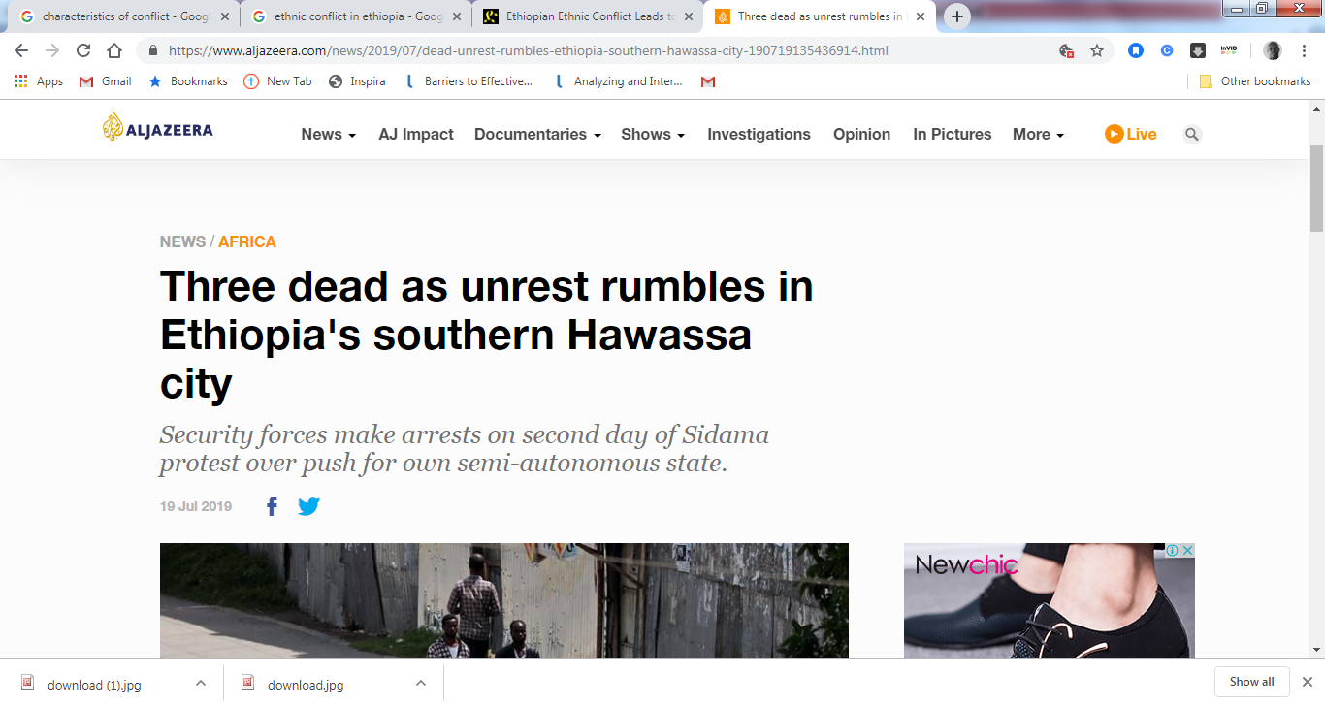

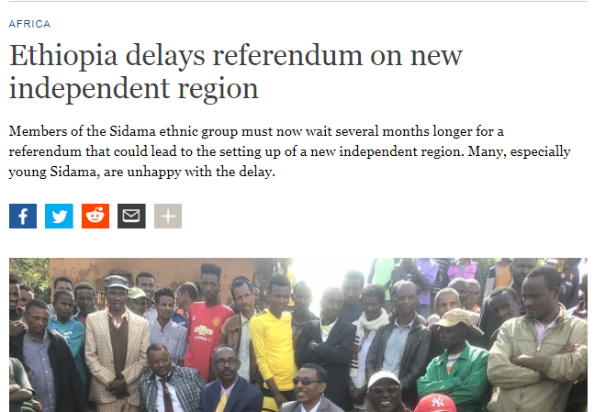

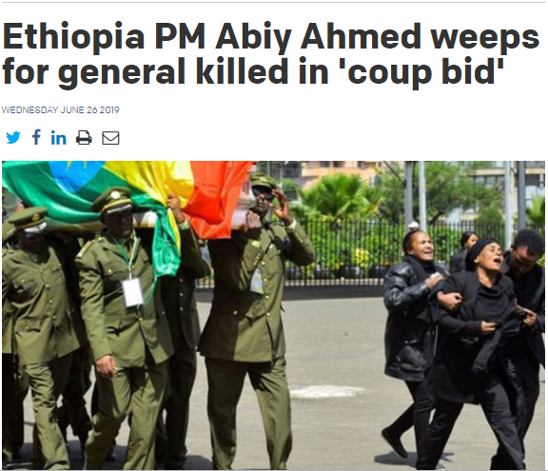

The aim of conflict analysis for journalists is to understand the causes, dynamics and the actors/forces who are promoting continued violent conflict. The more we know about conflict, its causes, dynamics and the ways in which it can be managed the better equipped we can be to report on events with the understanding and sensitivity that enables us to make a constructive contribution through good journalism. Objectivity in reporting conflicts is often killed because journalists cannot discern between truth and false information especially when they are given by news sources.

The aim of Conflict analysis for journalists is to achieve reporting that:
- Upholds the principles of conflict sensitive reporting
- Identify perspectives of all important conflict parties before doing their stories.
- Goes beyond obvious conflict symptoms to the issues that warrant public attention.
- Explore the sources and effects of the conflict towards wholesome reporting.
- Explain the historical and social context that help project the context of the conflict.
- Examine the escalation or de-escalation of the conflict for public awareness and interventions
- Examine stakeholders’ options and their implications with regards to its watchdog role
- Analyze attempts to negotiate or bridge gaps and objectively report on such with greater ability to do analysis of such efforts based on clear understanding of conflict.
- Determine an effective style and medium for reporting on various forms of conflict
- There are various issues that journalist should understand with regards to coverage of conflict.
- Whether journalists seek to influence a conflict or not our coverage will always have the potential to impact on whether a conflict develops positively or not.

The ability of journalists to make constructive contribution depends on the degree to which we are seen as credible by all of the parties involved. Journalists should not promote particular solutions to conflict but we can help people to make decisions by examining the strengths and weaknesses of available options. This is where conflict analysis helps in opening up perspectives, options and areas where parties to a conflict may not be able to see.
Ethically and professionally, journalists cannot censor news to avoid upsetting or angering people but we can offset some of the hazards of exaggerated rumors which promote fear and violence. However, Journalists can become more effective reporters of conflict and violence if we take the time to read and learn about these complex phenomena. What is needed with urgency in the newsroom is journalism which explores each side’s particular difficulties, such as politics or

2.6 Characteristics of conflict that necessitates conflict analysis
Comprehension of the phenomenon, appreciation of its causes and consideration of its complexity is necessary to analyze, comment or even report on it in a manner that yield positive dividends by raising demands for peace-building. The common characteristics of conflict situations that necessitate conflict analysis for journalists include:
- Multiple Actors: Who are the major actors and what is their role in relations to conflict
- Prolonged Duration: Long conflicts are often convoluted and needs critical understanding
- Complex Issues: Conflicts are sometimes based on multiplicity of issues in maze-like fashion
- Perceptions: The perception of parties and audiences to the conflict are often shaped by the media. A thorough understanding of this is absolutely essential.
- Social-Psychological Factors: The social and psychological factors are characteristics of the conflict should be understood better.
- Geopolitics: Conflict is not often restricted by geographical boundaries and it is important to understand the dynamics of the same.

2.7 Seven Tough questions that Journalists need to ask before covering conflict situations
i. Do I really understand what is happening?
Conflicts are often deep-rooted, intractable and dynamic in nature and quite complex for
simple coverage. This is compounded by the fact that coverage of conflict had tremendous
implications in terms of conflict transformation. This necessitates journalists to undertake a
thorough conflict analysis to understand the actors, structures and dynamics of conflict.
Considering the fact that what news sources say during interviews represents their positions and not their interests. Journalists are often posted from one place to another, this necessitates that they understand conflict analysis within their new areas of posting.

ii. What are the underlying causes of the conflict?
Parties to a conflict sometimes frame the conflict in very simple terms that reflect positions and not interests. This may be shaped by the fact that they see the underlying causes in different perspectives. Some conflicts have a long history and may have spiraled into revenge
missions and often embedded in the culture of conflict parties. In most cases such types of conflict are characterized by raw emotions, fear, humiliation and anger which very often override the substantive concerns of the parties. Good journalism aims to explore both the superficial and substantive issues in its reporting.

iii. What are the possible impacts of conflicts on different parties to a conflict
Journalists should be able to build and report on various scenarios of the possible effects of the conflict. Sometimes the parties do not understand the full costs of the conflict and the potential benefits of a settlement and resolution of such conflicts. If journalists are able to represent an assessment of potential effects on various parties then reporting can help in conflict transformation.
iv. Where are you getting your facts?
Factual disputes are rampant in complex, intractable conflicts. Sometimes this occurs because facts are hard to obtain or understand; sometimes each side claims different “facts”.
Journalists should take care to do balanced and careful fact-finding before believing any facts about what is or has been going on.
v. What are the full effects of the conflict on different constituency groups?
Conflict participants, particularly those most directly involved in the struggle, often don’t
really understand the full cost of the conflict and the potential benefits of settlement or resolution. Doing an assessment of the human, as well as monetary costs, of the conflict on the primary parties, the by-standers (people caught in the middle) and on allies and neighbors of the disputants often reveal an overlooked picture of the conflict situation
vi. Are parties to the conflict presenting their positions or interests?
Journalists should be able to discern the difference between interest and positions. The classic story to illustrate this describes two sisters fighting over the only orange in the family larder. Each sister must have the entire orange for herself, any less is impossible. A wise parent asks each of the girls (in private) why she wants the orange. One explains she wants to drink the juice; the other wants to use the rind to cook a pudding. What each sister wants is her position, why she wants it is her interest. In this case, the simple solution is to give the cook the rind after the juice has been squeezed for the thirsty sister - thus meeting the interests of both.
vii. Will my stories contribute to conflict escalation?
Media coverage often contributes to escalating a conflict. Sometimes this is desirable; constructive escalation is sometimes the best way for lowerpower groups to gain power to effectively advocate for their needs. In other cases, escalation gets out of control, and leads to increasing polarization, violence, and costs to all sides.

2.8 What is Conflict Analysis
Conflicts are dynamic and fluid situations. Each conflict as reported by journalists will require in-depth analysis of the issues at the heart of the conflict, although these will vary with each context and over time. Rarely do we find journalists who are narrowly specialized in conflict
reporting in the newsroom. The need for knowledge on conflict analysis stems from the understanding that at one point or another, journalists are engaged in reporting of conflict. Such conflicts can range from political exclusion and questions of governance to economic issues such as lack of inclusive development or the equitable sharing of benefits from a country’s natural wealth. 19In one context, a specific issue such as access to land might need to be analyzed; in another, political structures, electoral systems and/or recruitment of personnel into public administration might be paramount issues.

What will journalists seek to understand through conflict analysis?
Conflict analysis enables journalists to understand the following about the conflict:
• The type of the conflict;
• The reasons for the conflict;
The causes and consequences of the conflict;
• The components and the different actors involved and
• The levels at which the conflict takes place.

2.9 Conflict Analysis and its aim towards conflict sensitive reporting
Conflict analysis aims to equip journalists with capacity to ensure conflict sensitive reporting. The provocative wording; use of adjectives; narrow view of conflict and partial reporting; become commonplace without journalists understanding of conflict .This additionally
happens without being conscious that they are contributing to the perpetuation of such conflict. Some of the tips towards conflict sensitive reporting can only be achieved with a thorough understanding of conflict situations.

- Report Conflict as Multi-Dimensional phenomenon
- Recognize Divisive Propaganda.
- Cover Both Sides of Conflict
- Subjective Interpretations Compromise Objectivity
- Conflict Vocabulary Should Not Be Used Imprecisely
- Being Judgmental is being Detrimental
- Opinions Are Not Facts

Journalists need to ask more questions towards understanding the conflict. More answers lead to more information on multi-dimensional aspects of a conflict. Information that is fed to journalists by parties at conflict suits their interests and not the interest of an independent media. Deeper probing with as many people related to conflict directly or indirectly leads to information that is important and essential to untie the knots that keep settlement of conflict a distant possibility. It is also important for the projection and reflection of diverse perspectives through the media.
Therefore, a conflict sensitive journalist applies conflict analysis and searches for new voices and new ideas about the conflict. Journalists’ reports on who is trying to resolve the conflict, looks closely at all sides, and reports on how other conflicts were resolved. A conflict sensitive journalist takes no sides, but is engaged in the search for solutions. Conflict sensitive journalists
choose their words carefully and try to be as objective as possible. This happens if they know what words are appropriate to use in specific context and what is not. This can only be done through conflict analysis.

2.10 Understanding conflict Dimensions for wholesome reporting
Understanding conflict dimension requires that journalists look critically at various aspects of conflict. Conflict causes can be defined as those factors which contribute to people’s grievances; and can be further described as:
• Structural causes are the pervasive factors that have become built into the policies, structures
and fabric of a society and may create the preconditions for violent conflict
• Proximate causes are the factors contributing to a climate conducive to violent conflict or its further escalation, sometimes apparently symptomatic of a deeper problem
• Triggers are the single key acts, events, or their anticipation that will set off or escalate violent conflict.

2.11 Methods of conflict analysis
Journalists can carry out conflict analysis through a variety of ways:
• The direct and immediate recording of events or observation. Since their work involve mostly field work, they are better placed to assess the situation through observation and registration of effects
• Measuring social relationships and the degree of relatedness among people : The analysis of all available information provided through various mediums for data storage or the study of documents;
• Interviews and meetings with conflict parties, and other interested parties;
• Carry out random surveys and general and specific inquiries.

2.12 Phases of Conflict in the Conflict Circle:
Conflict is conceived of as a circle consisting of different phases that can reoccur unless the circle is broken. Journalists need to understand the phases of conflict. The phases are: submerged tension, rising tension, violent conflict and post-conflict. The goal of activities promoting peace and security is to escape the vicious circle.

Submerged Tension: Submerged tension refers to underlying conflict motives, which can be caused by structural instability in a country or region. These often appear as greed or grievances from various population groups and elites in the society. In the long run, these grievances can increase the risk of political instability and armed conflict. Submerged tension is very common phase during electioneering periods and it is important that journalists understand the causes of the submerged tension.
Rising Tension: Rising tension refers to a situation in which grievances increasingly are accompanied by violent demonstrations and open protests. Often an open political power struggle is underway, and political violence has increased. The situation often includes gross violations of human rights and/or threats of violence. This situation entails the risk of armed conflict.
Violent Conflict: Incompatibilities or differences between groups of people that result in organized violence. This can range from violent confrontations and manifestations in society, such as violent riots and massive crackdowns on protestors, to wars, genocide and massacres.
Post-Conflict: The situation following open confrontation. Post-conflict need not be the end of the conflict, as it can also entail the beginning of a new conflict if developments do not move in a favorable direction.

With a clear understanding of conflict situations, the media can play the following roles in various stages of conflict:
• Submerged & Rising tension: The media can play a critical ruling in this stage, the media
publicizes the competing interests of conflicting parties, which may lead to a conflict situation, with a view to striking common grounds for a negotiated settlement of differences and thus raise demands for peace. Conflict analysis in this stage helps journalists understand the critical and competing interests by the conflicting parties.
• Violent Conflict: The media with a knowledge of conflict analysis empowerment can brings to fore its human, economic, social and political impacts and thus be able to reinforce the path towards the de-escalation of conflict.
• Post-conflict: The function of the media at this stage of conflict is to keep an eye on the enforcement of peace agreements that have been put in place by competing parties and ensures that they are being implemented judiciously.

2.12 Conflict dynamics
If journalists are to report more accurately and effectively on issues of conflict, they have to examine all palpable evidences regarding the conflict dynamics. The analysis of conflict dynamics is a critical step in the conflict analysis process that explores the interaction
between the conflict situation, the stakeholders, and the identified causes of conflict. Analyzing conflict dynamics involves examining the different elements that relate to the conflict. Some of the factors that are considered include: connectors and dividers, triggers, accelerators, conflict drivers, conflict trends and possible scenarios.
The idea that conflicts have beginnings and endings is highly irrelevant in contemporary conflict situations. Conflict is a dynamic social process where the original structural tensions are shaped by the massive disruption of the conflict. Very often the root causes may become irrelevant in prolonged and protracted conflict of the contemporary society.

Conflict triggers
Triggers are isolated events or occurrences that are capable of starting or escalating conflict and violence situations. When there exists prolonged instability and high tensions then the condition favorable for triggers are rife. A good example of a trigger is the Tunisian street vendor who in December 2010 set himself on fire after being harassed by the police, and whose death triggered a wave of mass protests in the entire Arab region. Other known triggers may include: election disputes, arrest or assassination of political leaders, drought, a military coup, flood, a strike that turns violent and other social media broadcasts.

Conflict drivers
Conflict drivers are normally issues and processes that fuel violence and lengthen the conflict process. Conflict drivers are normally dynamic and they evolve over time and sustain violence. Controversial debates abound as to the nature of conflict triggers and drivers and
as to whether it is greed (the fierce competition over resources) or rather grievance (the uneven enjoyment of universal rights) that really drives conflict. Examples of conflict drivers in Kenya and many parts of the world include: corruption, poor accountability system, ethnic, regional and gender-based discrimination, presence of natural resources and their uneven distribution.

Conflict trends
Conflict trends are common patterns that feature conflict and political violence in one country. These patterns can be periodical events or precedents that recur in a cyclical way over a certain span of time. For instance, the regional rather than national dimension of conflicts is a recurring pattern of violence in Sudan. In Kenya, a cattle rustling has been a major trend that has been facilitated by commercial interests. Trends are a critical element to consider when developing potential scenarios.

2.14 Analysing the Actors
i. Interests: what interests do they have in relation to the conflict and how do these interests
influence the conflict?
ii. Relations: what are the relationships between the various actors?
iii. Capacities: what capacities do they have to influence conflict either positively or negatively?
iv. Peace Agendas: do they have an interest in peace? What kind of peace do they want?
v. Incentives: what kind of incentives could be offered for them to choose peace? Or disincentives to engage with violence?

2.15 Key issues to consider when undertaking conflict analysis
Issue One: Consider the underlying structures and causes that created the grounds for the conflict
Every conflict has many causes. Some causes seem more obvious, conspicuous and prominent as compared to others. Journalists should start by defining the key sources of tension and root causes of conflict. Some of the crucial structural factors that journalists should be look at include; the economic development and equity of distribution of the area under conflict, the existing political system and structures, democratic structural causes, respect for human rights, natural resources, the environment, and other sources of violent conflict or positive structural influence. Additionally, journalists should look at the ability in terms of strengths and weaknesses of existing formal and informal institutions to address grievances that can potential lead to conflict. They should also examine avenues of opportunistic behavior by conflict actors and other actions that can further the interests of confrontational actors. Therefore, it is crucial to analyze the underlying structures and root causes as thoroughly and historically far back as possible.
Issue Two: Consider the most recent causes of conflict and why the conflict continues unabated
When analyzing the causes of conflict, journalists should consider the difference between the deep underlying causes that created the grounds for potential conflict, but also the more recent causes. Among these “proximate causes” it is important to describe the conflict dynamics and, for example the way the war economy functions. If conflicts take long, they are in fact creating their own causes. This level of analysis will not identify why the conflict started but why it is continuing. It also describes some of the causes that directly relate to the underlying causes.
This is especially important for conflicts that have persisted for decades without solutions.

Issue Three: Consider who the actors and stakeholders in the conflict. Describe how and
why they are the conflict’s stakeholders
Journalists need to fully understand which actors there are in the conflict and what their role is. Try to describe all conflict-related actors at all levels (including Governments, armed groups but also civil society actors, donors, international actors and communities, individuals, men and women. The focus here is those actors causing and fueling the conflict. When analyzing the actors, focus on their incompatible interests in terms of greed and grievances and how these factors affect and are affected by ongoing and potential violent conflicts. Fear is a strong driving force of actors’ behaviour in situations of insecurity. Examine various actors’ expectations and possible gaps between these expectations and how they are met. Analyse the power base and resources of key actors and also include the power analysis that identifies structures and power relationships between actors.

Consider the impact and source of the attitude of conflicting parties to the conflict
It is important for journalists to consider the attitudes and perceptions of parties involved in the conflict because it shapes their behavioral reactions. Before doing a conflict story, try and understand the underlying attitudes, motivations and perceptions which are largely shaped by the context in which people are living in. It is also compounded by the experiences that they have had before. While doing analysis of attitudes, journalists should strive to understand the source of perceptions that fuel violent behavior in the conflict. Include perceptions among civilians that are older, rooted in the culture as well as the attitudes and perceptions of violent actors. It is important to also consider the changes in attitudes that are a result of the conflict.

2.16 Conflict Mapping
Conflict mapping is the systematic process in which a conflict is critically analysed to help both the interveners and actors of the conflict in comprehending its root causes and nurturing its possible reduction, management or solution. Mapping a conflict gives us a kind of ‘bird’s eye view’ of the problem. It is a way of graphically representing the issue, showing everyone’s perspectives on it, and getting sufficient distance to see issues and ideas which may otherwise go unnoticed. The conflict mapping focuses on actors and their interrelationships. It is a good tool to start analyzing a conflict.
As conflict emerges and develops gradually, it produces a complicated mesh of confusion and uncertainty. Very often the growth of conflict changes a number of dynamics because interactions between the conflicting parties changes and this sometimes radically and abruptly. Most often-and this is a factor that is evident in majority of conflicts- the levels of unpredictability, uncertainty and emotion rise. Most often when this happens, unwise and costly decisions are rashly made from a lack of understanding of what is occurring.

Conflict mapping for journalists aims to understand the following elements of a conflict:
• The subjects (who takes part in the conflict?)
• The interests and goals (what do the subjects want and how do they intend to achieve it?)
• Power (what resources do the subjects have for obtaining their interests?)
• Awareness (who is recognised as an interlocutor for the resolution?

The frames of reference (what are the presuppositions, paradigms or prejudices the agents harbour unconsciously?)
• The emotions (what role do the emotions play in this conflict?)
• The relation (how is the relation between the subjects structured?)
• The coalitions (what coalitions can be generated in this conflict?)

Very often, relationships between conflict actors can change over time; new parties can join the conflict, or the nature of the conflict can change due to different interactions between stakeholders. It is important that journalists are able to repeat the exercise to discern changes in relationships before they report especially when the conflict span a long period of time and keeps erupting from time to time. How can journalists determine and identify if they need to do a conflict mapping, the following indicators/ questions are very necessary for the same:

• History: Is there a history of conflict in the area you are working in?
• Neighbours: Is there a history of conflict in a neighboring village, region, ethnic community or country?
• Disputes: Are there disputes between people or groups, perhaps over water, land, grazing access or aid?
• Hostility: Have communities or groups been openly or overtly hostile?
• Change: Have there been dramatic social hanges in the past 5–10 years?

2.17.1 Timeline tool
The Timeline is a tool that helps to review and to sort key events in their chronological order of occurrence. By listing the events as they took place in a certain period of time, the Timeline visualizes how these events relate to one another. Through this we can better understand a singular event in its context, as we can see the incidents leading up to it, as well as its consequences. Especially in the case of a present conflict, the Timeline helps us to grasp the significance of an event in the more complex conflict dynamics. The figure above is a Timeline template. On a bar, we list events and plot them over time, from the earliest to the latest. Then, when appropriate, we draw a bar representing tension or frustration over the events. The measurement of tension depends on the public’s perception gathered by the journalist. With these facts, supplemented with data such as the names of the characters involved, a journalist can write a story. The frame of a story as constructed this way will be episodic.
It will be anchored on an event: how a killer fire hit a village 10 minutes past midnight, how it took fire fighters 20 minutes to arrive, and how it took 30 minutes to stop the blaze. The story will be no different from other stories on fire that the public has read before. Now, imagine how a story like that could possibly improve public discourse and discussion on fires, and contribute to resilience to similar hazards in the future.
It cannot. And because the story, as written, makes no contribution at all to improving the quality of public discourse and discussion, the story fails as a work of quality journalism.
For a story to improve the quality of discourse and discussion, it must make the unknown known. The journalist has to take that essential “next step” of analyzing the gaps in the data, which then leads to raising further questions. Sometimes, these gaps are just voids in time. Other times, the logic of cause and consequence in the Timeline becomes painfully inconsistent. For example, why did it take the fire trucks 20 minutes to arrive? Likewise, why did it take them 30 minutes to put out the blaze? And, what can be done to prevent a similar delay from happening again? These questions, collected, assessed and refined, are one of the journalist’s most powerful tools in writing a meaningful story. Answers to these questions can sometimes be more relevant than “Hour-long fire hits village, kills one.”

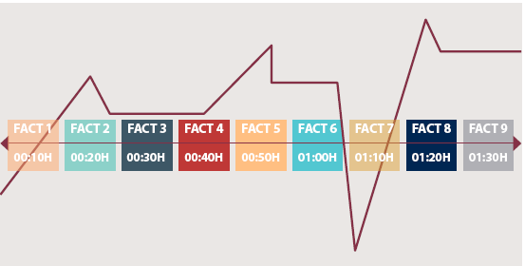

2.17. 2 Conflict Onion
Conflict Onion is often used to express the interrelated dynamics of positions, interest and needs among conflicting parties. Groups approaching conflict from a competitive standpoint will tend to express demands about what they want and how their opponents should behave. What is generally presented among conflicting parties are only positions (the visible outside layer of the onion) which conceal underlying interests (the deeper layers) which are representative of the group’s real needs (the layers at the core of the onion)
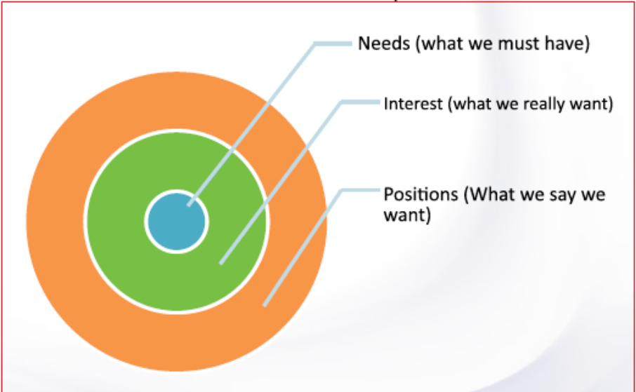

2.17.2 The ABC Triangle
The ABC triangle is a handy tool in understanding the various components and dynamics of conflicts. Using this model allows one to differentiate between different ingredients involved in a conflict, providing us with an understanding of its most significant aspects. Understanding the components of a conflict, or the elements it is made up of, is just as important as understanding who the actors are or what caused it. The model proposes that conflicts consist of three basic components:
(1) attitudes,
(2) behaviour and
(3) contradictions.
These can be identified in every single conflict, although to different extents. The components
are placed in the three corners of a triangle to illustrate the mutual relationship between them

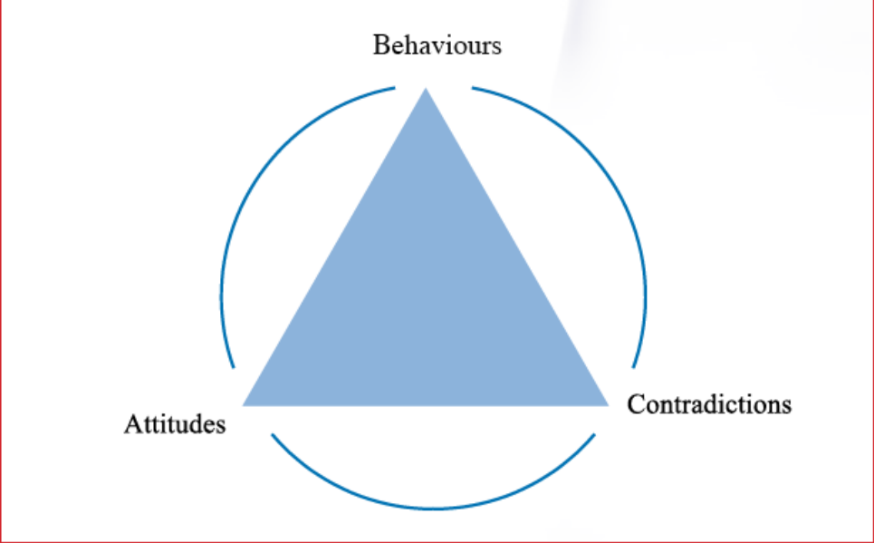

i. Attitudes
Attitudes consist of the party’s thoughts, feelings and desires. Often times, our attitudes and our assumptions about the conflict lie beneath the surface and are not always overt. Feelings refer to those emotions the conflict parties have for each other, and also the ways the conflict parties consider and deal with their own feelings. Attitudes also cover our presumptions and subjective ideas about the underlying issues in the conflict, about what has happened, who did what. Journalists have to consider the objective and subjective dimensions of how the causes of conflict are reported. The story and the perceptions of what has occurred change as time passes and as the parties become increasingly distant from each other during a conflict that is escalating. A continuous assessment of long terms conflict should be done by journalists before reporting. Attitude refers to feelings of hatred, distrust, and apathy, the transforming potential of these attitudes is to develop feelings of empathy.

ii. Behaviour
This consists of the visible aspect of a conflict and is what sensational journalist dwells mostly on when reporting on conflict situations. Human reactions to events are rather complex, so what is referred to as behavior really consists of many elements. Different people react differently to different events. Nevertheless, the actions that combine to make the behavior as it is understood in this model can usually be divided into three categories: what the actors said; what the actors
did and the existence of physical violence. Often times, what is not said or not done (non-action) can be considered part of behaviour. Avoiding action can have an equally important effect on the development of a conflict as action would, probably simply with different consequences. Physical violence is treated as distinct from other actions because the use of violence changes
the character of the conflict drastically.

iii. Contradictions
The root cause of conflicts is based on the issue of contradictions. The model proposes that conflicts are usually about three basic types of issues: distribution, position and order. The contradiction with regards to distribution arises because there is competition for resources that have to be divided among different actors. Contradiction emerges as a result of competition over a position. A position is understood as a resource that cannot be shared. This is because only one person at a time can hold a given position. Contradiction with regards to order emerges over the rules that should be followed by a given society or within an organisation, with at least one party claiming that the current rules are not adequate or fair and wanting to change the prevailing system. Order conflicts can be more intense than the two other forms of contradiction already mentioned, since the core values of those involved are challenged, and core values are very difficult to negotiate. The premise of ABC triangle is that since a conflict can start in any corner, it can also be stopped in any corner.

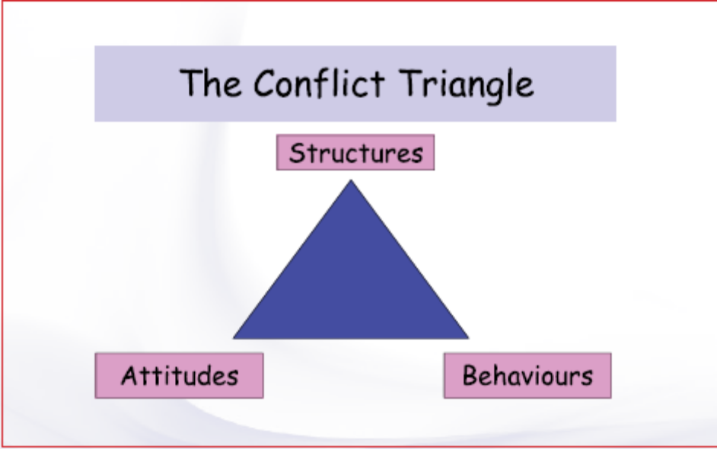

2.17.3 The Conflict Triangle
This Conflict Triangle analyses certain basic elements often present in conflict. One way of conceptualizing the relationship between these elements is a triangle with Attitudes, Behaviours and structures at the tops of the triangle. Each element influences and is influenced by the other elements.
Attitudes include the parties’ perceptions and misperceptions of each other and of themselves. These can be positive or negative, but conflicting parties often tend to develop demeaning stereotypes of the other.
Behaviours can include cooperation or coercion, gestures signifying conciliation or hostility. Coercive behaviour might include threats, pressure of different types and violence. Co-operative behaviour could include: recognition of rights, setting up of joint (economic) projects, trust building measures, negotiations in good faith, etc.
Structures refer to the political, economic, societal mechanisms, processes and institutions and history that influence the distribution and satisfaction of basic needs and interests of people. Conflict is a dynamic process in which structure, attitudes and behaviours are constantly changing and influencing one another.

2.17.3 Conflict Tree
The conflict tree deals with the difference between structural and dynamic factors, visualizing how conflict issues link these two aspects. When using this form of analysis, you may find that a recurring issue can be identified as both a cause and an effect of a particular conflict. An example of this is the scarcity of natural resources, which can be a source of conflict, but also an effect of prolonged violence. The conflict tree can also illustrate the cycle of violence, and the ways that communities can become trapped by the causes and effects in a perpetual cycle of conflict.
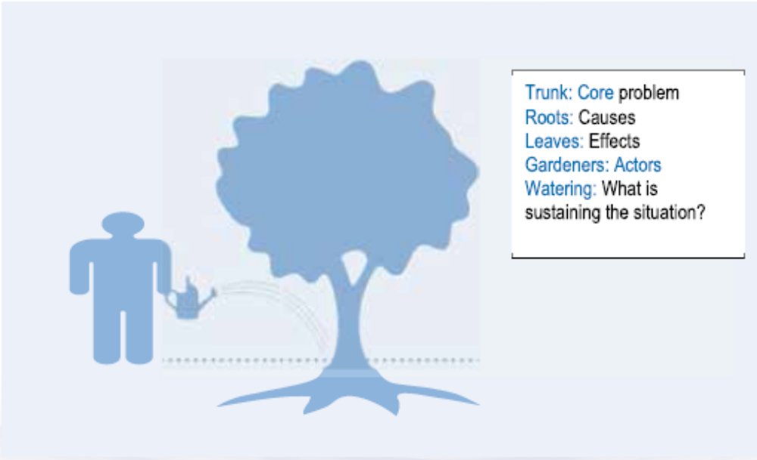
The problem tree methodology enables us to visualise links among different conflict factors (root, intermediate and immediate causes). The tree visualises the interaction between structural, manifest and dynamic factors. The roots symbolize structural “static” factors. The trunk represents the manifest issues, linking structural factors with the dynamic factors. The leaves moving in the wind represent the dynamic factors.
Dynamic Factors: Dynamic factors include the form of communication, escalation level, relationship aspects etc. Working with dynamic factors involves a short time horizon; reactions to interventions are quick and at times unpredictable. Examples are diplomatic interventions, or multi track conflict transformation dealing directly with the form of interaction between the conflict parties. Quick money is often more important than big money when addressing dynamics factors.
Manifest issues: Issues are what the conflict parties want to talk about, the “topic” of the conflict.
Structural Factors: Root causes are the basic “reason” of the conflict. They are difficult to influence on a short time basis, if they are avoided, however, the conflict may pop up again later. This is the typical area for development cooperation, longer-term involvement
and the prevention of structural violence (Human Needs Theory).
One would likely identify both “proximate” and “structural” causes of the conflict, whereby the former are those issues that appear closer to the ground surface and the latter would appear deeper underground. Moreover, you should not assume that the relationship between root causes, the prioritized conflict and the effects will necessarily be linear; root causes may be linked to each other, while effects if unaddressed can feed back into the process and become causes for new conflict. Moreover, the perceived causes and effects of a conflict can differ according to social groups and status (i.e., gender, age, wealth, ethnicity, etc.). These complicated relationships and differing viewpoints should be kept in mind and if possible, marked on the tree.

2.17.4 The Iceberg Model
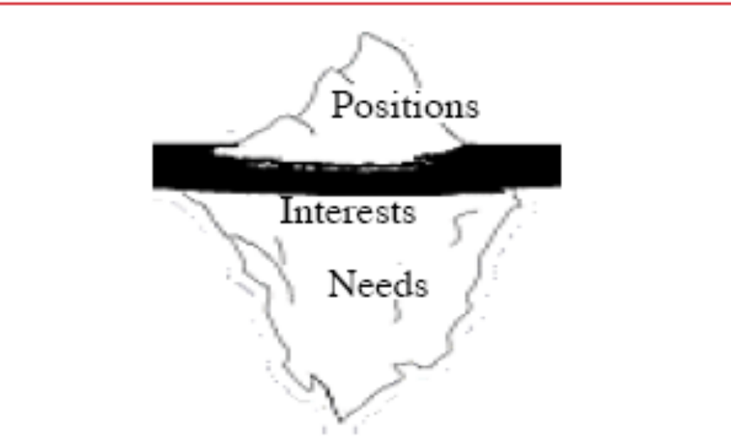

Like in the case of an iceberg, there are those things that are obvious on the surface while there are those that are underneath. Compared to conflict, some things are obvious to the disputants that reflect the dynamic between them, the issues in dispute, and other aspects of the existing dissension. These are above the water level line.
Below the water line is much more. There are hopes, expectations, emotions, needs, values, beliefs, and other deeply held views and feelings. Our individual and collective histories that we bring to the issues in dispute are in the mass below the surface, too. While, for all intents and purposes, this underlying mass appears to be unnoticed or remains unspoken, it has an enormous impact on the interaction. Indeed, it is an integral part of the conflict and who we are within it, within ourselves, and within the relationship One of the classical ideas in conflict resolution is to distinguish between the positions (i.e. concrete demands) held by the parties to the conflict and their underlying interests and needs. Interests are often easier to reconcile than concrete positions, since there are usually several positions that might satisfy them.
For example, two neighbours quarrel over a tree. Each neighbour takes the position that the tree is on her land (positions: “The tree is on my land.” “No, the tree is on my land.”) No compromise is possible, since the tree cannot be sawn in half. It turns out, however, that the interest of one neighbour is in using the fruit of the tree (Interest: “I want the fruit of the tree.”), and the interest of the other is in having the shade (Interest: “I want to sit in the shade.”). The positions may be irreconcilable at first, but the interests might be. New positions can be found to satisfy the interests of both parties.

2.18 Dos and Don'ts in Conflict and Peace Building
When reporting on conflict and peace building efforts, it is important for journalists to examine their own motivations for such assignments, assess who they are working for, and make a genuine assessment of the stance they have taken. Neutrality is important for positive media contributions to conflict resolution or de-escalation (Puddephatt 2006; Hamelink 2008). Journalists must do their own research into causes of conflict and ask all vital questions in order to gain an understanding of the issues involved and analyze the conflict to establish its antecedent factors, trajectories, and current status. This means journalists must ask the right questions about parties involved in the conflict to find out if sides have already been formed and hearts hardened. They must also find out whether there are shadow parties or invincible hands behind the conflict and who provides factions with weapons, ammunition, and money. These analyses will help the journalist know or determine to whom to speak.
In covering conflict it is important for journalists to observe the following:
• Go to the field to speak to parties in the conflict rather than rely on secondary sources or even telephone interviews.
• Meet with all parties to appreciate the issues and to build confidence and trust.
• Aim to find a solution by talking to other actors such as mediators.
• Tell a compelling story that can appeal to the conscience of factions.

Focus on costs of conflict such as loss of lives, destruction of property, erosion of goodwill, and setbacks in development. Stories journalists tell should appeal to the conscience of the factions to stop the conflict. It is important to highlight the fact that, for example, when professionals flee from conflict zones it affects education, health care, business, and projects such as the construction of schools, roads, hospitals, etc. As has been noted by Aapengnuo (2008, 1), “there are growing concerns about the impact of these conflicts on national and sub-regional security and stability. Their impact is most felt in the area of economic growth and development.”
Conflicts and violence often result in the loss of lives, burning of houses, farmlands, farms, and produce as well as other property, including state assets. Monies meant for development, such as the building of schools, roads, etc., are rather spent on peacekeeping. Teachers fleeing conflict areas affects education, health officials leaving their posts affect healthcare delivery; businesses relocating elsewhere affects economic expansion, job creation, income, and leads to unemployment and despondency. These are the true costs of conflict and people in conflict areas must be informed through good reportage.
Media reportage is, therefore, crucial to bringing conflicts under control. Professionalism and ethical behavior call for journalists to be as faithful to the truth in their reporting as possible and be mindful of their own attitudes and composure. Journalists must strive for neutrality, putting aside their prejudices and avoiding color, embellishments, slants, or their own positions. They must also give all parties an equal chance to be heard and not neglect the voices of the minority. Allowing parties to propose solutions to the conflict can also make them feel a part of the peace-building process and encourage them to do more.
(Margaret Amoakohene The Role of Media in Conflict and Peace-Building, Conflict-Sensitive Coverage: A Manual for Journalists Reporting Conflict in West Africa)

Part seven: Reporting tips
While it is hoped that the suggestions made in part Six will provide journalists with a range of different strategies that they can adopt or adapt in covering different conflicts, this penultimate part of the toolbox will concentrate on a range of more practical issues journalists should consider when reporting on conflict. Most of the points made in this section were based on observations made by members of the editorial team as they reflected on their own experiences of covering conflict. These ideas emerged during discussions, with one person’s ideas sparking another’s. Part Seven begins by capturing a few simple, but very useful points that were made by the group during our discussions. We then explore some ideas about the role and importance of interviewing in conflict reporting, before focusing on the importance of editorial collaboration in the comprehensive coverage of conflict.

2.19 Some practical tips for conflict reporting
Members of the editorial team share a wide range of experiences in covering different forms of conflict for different types of media organizations and this collection of brief tips draw directly on their experience. Many of these ideas speak to each other and there are strong links between the different ideas. It’s likely that you may already be doing many of these things in your reporting, but if not, they are all worth considering.

Be Proactive
The editorial team agreed that journalists should not sit back and wait for conflicts to erupt. Instead we should be monitoring the communities we work in and looking out for the signs of emerging conflict As soon as we observe the signs that a conflict may be moving from a latent to an emerging state we need to start speaking to people on the ground to get as many view points as possible about what is happening.
This will ensure that we are well informed when we approach the main stakeholders about the conflict. James Mphande stresses that journalists should avoid being reactive. James says that:
If we wait for the spin doctors to come to us we are limited by the agendas they have planned, but if we are approaching them proactively with carefully crafted questions we can get a proper understanding of what is going on.

Cultivate Sources
Journalists can only be proactive if they have their ears to the ground and are in contact with people who know what is happening in a community. The only way this can happen is if journalists get out of the newsroom and spend time in communities meeting people and making contact with a wide range of organisations. Find out about the local NGOs and CBOs that are working in your area, spend time talking to small business owners and make contact with the local churches, mosques and temples. Take the time to introduce yourself to people from civil society organisations, social activists and unionists. Make contact with individuals — not just spokespeople — in the police and different departments of local councils and get their contact details. Check in with these people on a regular basis. A weekly or fortnightly phone call costs little, but keeping in touch with a wide range of regular sources often results in great stories. These are often the people who will be able to alert you to the rise of tensions and possible conflicts in communities sometimes well before they break out and at a point where your stories can contribute to preventing conflict before it erupts.
Making contact with a wide variety of people can also be critical during times of highly escalated conflict when certain parts of a community become no go areas or when you simply do not have the time and capacity to visit many different parts of a community. These contacts can give you tip-offs about what is happening, describe what they are experiencing and help you to verify claims being made by the parties involved, the authorities and other stakeholders. For radio stations covering violent outbreaks, these sources can also help you keep audiences updated about where violence is taking place and which areas they should be avoiding.

Keep a cheat sheet
Barbara Among recommends that journalists should develop a database which contains all of the important information they are likely to need when reporting on conflict. This could include historical information about previous conflicts, dates and the names and positions of the different stakeholders. It can also include information about key commitments that have been made by different leaders with regard to the conflict. This resource should be continuously updated. Describing her approach Barbara said: When I was actively covering the northern Uganda conflict I had a small book where I would register the events, put the date and time,
what happened and the people involved. I kept the book and it was easy to refer to instances in the past, because I knew exactly when it happened, during what time. When I was going to do stories I had the records, created my own database. Having a “database” such as this available means that journalists reporting from the field are equipped to provide stories that help to contextualise the conflict. It’s especially useful for broadcast journalists who are providing regular live updates.

Lost in translation
For journalists who are working in multi-lingual societies there is always the danger of translation errors which can distort the essence of what people have to say. It’s clearly important for journalists to be as careful as possible when translating quotes into another language and to double-check everything. However, even when a translation is technically accurate there is always the possibility that the nuance of what the person is trying to say may get lost.
Where possible it is often advisable to paraphrase what someone is saying rather than to quote them directly. Alternatively, journalists can make it clear that the quote is a translation, for example: ‘Speaking in isiZulu, Mr C said: “translated quote”.’ This alerts the reader to the possibility that the translation into another language may not be absolutely reflective of what Mr C said. For radio the technique of starting with the original speech before fading this down
and bringing up the translation achieves the same effect.

Being explicit about reporting constraints
There are times when journalists may have to rely on others to gain access to conflict arenas and in these circumstances it’s important for reporters to be clear about the restraints they may be experiencing with regard to their reporting. Journalists who accompany military or police patrols into conflict zones are often accompanied by “minders” who ensure they do not speak to
certain people or visit certain places. Under these circumstances it’s vital for journalists to be clear about the fact that their reports are unlikely to reflect what is really happening on the ground. The same can be said for situations where journalists accompany aid agencies or ambassadorial delegations into the field. These agencies are often as keen as the military to control what appears in the news media and it’s important for journalists to be upfront about the extent of the support they have received from these groups. or whether or not they have received support.

2.20 Components of stories with good background of conflict analysis
Principles of Conflict Analysis for Journalist
i. Journalists should strive to seek information from various actors in the conflict area; conflict analysis by journalists must be based on a wide range of views about the sources of conflict. Conflicts are about perceptions and the meanings that peopleattribute to events, policies and institutions hence the need for variety of viewpoints.
ii. Journalists should note that analysing a conflict is not an emotion-free exercise. As a matter of fact, peace-building is a value-based engagement and journalists must beware of subjectivity and bias creeping into your analysis. It is better placed to engage all sides and appreciate the situation more clearly, if you engage in your analysis with an open mind.
iii. Journalists should also understand that conflict analysis is not only relevant when there is visible violence. There are stages where the conflict has not fully manifested in the form of violent conflict and this does not mean that the conflict analysis
should not be done.
iv. Conflict analysis is done in participatory or non participatory ways hence journalists in their experience in reporting should contribute to conflict analysis process within their areas of operation.
v. Journalists should be able to understand that a conflict analysis is not a ‘one off exercise. Good practice implies that periodic updates are planned for to capture effectively the dynamics of the conflict. More especially for journalists who are posted to new areas, conflict analysis is very important.
vi. Maintain at all times ethical journalistic principles of professional reporting, foster a dispassionate stance toward any issue in a conflict while avoiding the status quo, ask tough questions of everyone despite discomfort, and push for access.
vii. Gender perspectives and dynamics should be integrated into a conflict analysis process. Conflict perspectives are influenced by gender dynamics. Often times conflict reporting by journalists are male dominated.
viii. Use solid information as the basis of the story rather than an emotional peg. Operate on principle rather than prejudging the outcome, and avoid finding the point of coverage that fits only one side’s narrative
ix. Conflict analysis is not a one-time process, journalists should engage in constant conflict analysis each time before they report by conflict situations are dynamics.
x. Reporting from the ground on conflict situations is always preferable in order to give accurate depictions of events, eyewitness accounts, and gather information that will put authorities in a position to speak directly to the issues at hand.
Demand access.
xi. A conflict analysis by journalists must be based on a wide range of views about the sources of conflict. Conflicts are about perceptions and the meanings that people attribute to events, policies and institutions.
xii. Offer a variety of coverage that can build the bigger picture. Avoid resorting to mostly human interest stories that rely on emotion to illustrate weighty issues, or using a zero-sum debt approach that ignores complexities of the situation.
xiii. Do not insert or package opinion into conflict analysis because this will be consequently transferred to the formal news coverage. Blurring this line can fuel distrust, misunderstanding, and resentment toward the media and between sides
of the conflict.
xiv. Conflict analysis helps journalists to reconsider their perspectives, which are often heavily influenced by emotions, misunderstandings, assumptions, suspicions and mistrust as informed by their sources. In conflict situations, emotion can easily overwhelm logic and reason. It is therefore important to distinguish opinion from fact.

2.21 Elements of journalists’ stories with a conflict analysis background
Stories done by journalists who have a good conflict analysis background should have the following elements:
• A clear, precise and informed background of the conflict and reasons for its occurrence.
• Specifically identifies the cause of the conflict and clearly separates between causes and triggers and goes beyond obvious conflict symptoms.
• Avoids subjective interpretations that can compromise objectivity of readers in understanding the conflict and stakeholders in dealing with the conflict.
• Avoids the reinforcement of stereotypes which sometimes damage perspectives of conflict.
• Carries a wide range of viewpoints, perspectives from different news sources involved in the conflict.
• Examines the options and strategies of various parties including the possibility for withdrawal, compromise or transcendence?
• Contains a gender specific perspective to the conflict with regards to news sourcing and actors. It also seeks to explain how different genders especially the women and children have been impacted by the conflict.
• Does not focus on dramatizing and sensationalizing the physical aspects of the conflict while ignoring the emotional and latent forms of pain and distractions.
• Names sources accurately and precisely after proper verification. The rule is named sources are always better than unnamed sources.
• Examines the escalation or de-escalation of the conflict for public awareness and interventions.
• Examine stakeholders’ options and their implications in the conflict with regards to media’s watchdog role.
• Avoids the personification of a conflict, so that an act of evil or good is not attributed to one person or group.
• Avoids assessing the merits of a violent action or policy of violence in terms of its visible effects only.
• Reports and focuses on both sides of conflict. By examining and reporting on the two sides’ misperceptions of each other, the media encourages disputing sides to revise their views and move closer to reducing conflict.
• Asks tough questions. Good stories seeks out the real meaning of what leaders say and looks beyond the leaders’ interests and seeks the larger groups’ interest.
• Asks the disputing parties for their solutions instead of just repeating their rhetoric of grievances.

3.0 Module 3: Ethics in Reporting Conflict

3.1 Interviewing people affected by conflict
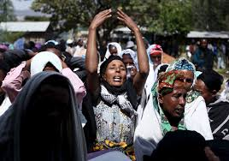
It should be clear from everything that we have discussed so far in this toolbox that interviewing lies at the heart of conflict sensitive reporting. We certainly must describe the behaviours of parties involved in in conflict, but it is only through our interactions with people that we can really come to understand their real needs, interests and why these things are important to people.
Likewise it’s only through conversations that get beneath the surface that we can come to understand how parties are experiencing conflict, what it is they fear and what it might take to allay those fears.
Conflict sensitive reporting involves speaking to people across the board. We certainly need to engage with the leaders of the different parties involved in conflict, with the heads of influential stakeholder groups and with peace-keepers and peace-makers who are involved in helping to resolve conflict. We also need to be to engaging with people on the ground who have little influence over the outcomes of a conflict; the people who have the most to lose and who will generally suffer the most. In this section we draw on the collective wisdom of the editorial team to share some tips for conducting interviews in conflict situations.

3.2 Some general tips for conflict sensitive interviewing
• Avoid phrasing questions in terms of winners and losers. When asking questions about goals, objectives and strategies encourage parties to move away from zero-sum game ideas. How we phrase a question will have an impact on how people respond. Asking, “What will it take to satisfy you?” is a very different question to “What will it take for this conflict to be resolved in a way that satisfies everyone?” The first begs a zero-sum response while the latter asks people to think more broadly. Both are fair questions, but the second is more likely to encourage a constructive response.
• Encourage interviewees to consider the other parties involved. Instead of just asking parties to outline their needs and interests – we should be trying to get beyond positions – we should also be asking them how they understand the needs and interests of others involved in the conflict.
• It’s not our job to censure interviewees, but we also do not want to be manipulated by parties who want to use our channels to further provoke conflict and to launch attacks on others. It’s often worth following up on insulting and provocative statements with questions that ask the person to take responsibility for his or her statements. For example: What kind of a response are you expecting from the other party in relation to your attack?
What are you aiming to achieve by insulting the other party?
• Be firm. Being conflict sensitive does not prevent journalists from being tough on interviewees when necessary. For instance if an interviewee is making claims that seem untrue or exaggerated we need to challenge them on these claims. Similarly if they make demands or promises that seem unrealistic we need to question whether what is being said is feasible.
• Listen carefully and paraphrase people’s responses back to them. We cannot afford to misrepresent what people have to say during times of conflict. Lives could depend on our getting a particular quote right. There is never any harm in making sure that you fully understand what a source is telling you. For example, repeat the interviewee’s position back to them, saying: “Am I correct in saying your position on this is ABC …?”
• It’s important to do your research in preparation for interviews, but if there are times when you do not know something it’s best to admit to that and to get clarity. Make it clear that it’s in everyone’s interests for you to get the story right and never be afraid to ask for clarification during an interview.
• Ensure that your interviewee has been given the best opportunity to convey their message in the way they want to get it across. Be as sure as you can be that what you say in your report will reflect what the person intended to say. Be aware that if you distort what people are saying you may well be aggravating or prolonging the conflict.
• Don’t put words into people’s mouths. Avoid the “Would you say XYZ…?” questions that are deliberately intended to get people to say what journalists want them to say. Rather take your time and be patients with speakers. Let them express themselves in their own words.
• Adopt a tone that suggests even-handedness. Don’t pretend to be a sympathiser and make it clear that you are interested in what everyone has to say.
• As journalists we often have to speak to people whose views and ideologies we find objectionable and sometimes deeply offensive. In cases like this, take the time to think about how your feelings might influence your behaviour in an interview. Be aware that unless you are willing to give the interviewee an opportunity to be heard you will not be able to contribute constructively to mitigating the conflict.

3.3 Interviewing people affected by conflict
• Don’t pretend to understand what someone who is caught up in a conflict is going through. Take the interview slowly and let the person tell his or her own story. There’s no harm in showing that you care, but this does not mean you sympathise with a particular group. Let people open up slowly and respect the fact that people may have experienced and seen things you may not even be able to imagine.
• Begin the interview gently and do what you can to make the person feel comfortable before you start asking the more difficult questions. Let the person know that they are in control of the interview. They can decide on how much or how little they want to tell you. It can help to ask probing questions, but be sensitive to the interviewee’s emotional needs. It can help to be silent for a moment or two to give people the chance to think and to collect themselves if they are feeling emotional.
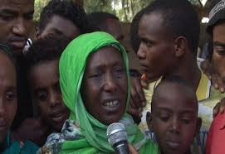
• Asking open-ended questions encourages people to tell their stories in their own words. Closed-ended questions leading to “Yes” and “No” answers tend to foreground the journalist’s thinking instead of the interviewees’ explanations.
• It’s often better to conduct one-on-one interviews with people who have experienced trauma, but this is not always the case. There may be times when a source will feel more comfortable if they have others there to support them. We need to make allowances for these requests to make interviewees feel as comfortable as possible.
• Be aware that, when conducting group interviews, the unexpected might happen. Interviews conducted in group situations can become challenging if people disagree with each other and begin to fight among themselves.
• Make absolutely sure that people understand how what they have said is likely to be used and whether or not he or she will be identified in the story.
• Be sure you understand what the source is saying. It’s often useful to end the interview by highlighting the points that you think you will use in your story, and checking with the source whether your understanding is accurate. It’s also worth checking on whether the source feels you are missing anything important.
• Be emotionally prepared. Journalists tend to get hardened over time, but there will often be cases where something about an interview or an interviewee touches us deeply. We need to be alert to that possibility and to think about how we will respond when this happens.
• Never make promises you cannot guarantee. The best we can generally do is to promise to try to tell the person’s story accurately and with respect so that others can understand what they have been through and what they need. We cannot promise that our stories will bring about change or attract international aid. Most of us cannot even guarantee our media houses will use the stories. It can be worth explaining that this decision rests with the editor.

3.4 Media conflict and Gender

Group work: Discuss the role and impact of conflict on women.

Gender refers to the socially constructed roles, behaviors, activities, and characteristics that a given society considers appropriate and imposes on women and men (World Health Organizations, 2016). Therefore, while most people are born either male or female, they are all taught appropriate norms and behaviors, including how they should interact with others of the same or opposite sex within households, communities, work places, during conflict, and in the peacebuilding process. The United Nations (2010, 5) defines peacebuilding as “a range of measures targeted to reduce the risk of lapsing or relapsing into conflict by strengthening national capacities at all levels for conflict management, and to lay the foundation for sustainable peace and development.”

3.4.1 Why Conflict is Gendered?
Conflict is gendered because gender determines who participates in conflicts, the roles they play, and who is targeted and how. Most societies have traditionally assigned the role of fighter or soldier to men (Sjoberg 2006). Men have, therefore, been given the responsibility to wage war in defense of territory, women, and children. Similarly, gender has played a role in the targeting of girls and women for sexual violence during wars. This targeting of women has occurred throughout history, including the civil wars in Liberia and Sierra Leone. Although combatants have also subjected men to sexual violence, they have disproportionality victimized girls and women. Nonetheless, girls and women play varied roles during wars. Some of them have joined fighting forces, sometimes under duress, and have also fed and ensured the survival of relatives and friends (Turshen and Twagiramariya 1998). Women have also worked, sometimes collectively, to resolve conflict and to build sustainable peace.
The UN Security Council Resolution 1325 on Women, Peace and Security, which was adopted in 2000, reaffirms the important role of women in the prevention and resolution of conflicts, peace negotiations, peacebuilding, peacekeeping, humanitarian response, and in post-conflict reconstruction. The resolution stresses the importance of women’s equal participation and full involvement in all efforts for the maintenance and promotion of peace and security, urges all actors to increase the participation of women in peacebuilding, and to incorporate gender perspectives in all United Nations peace and security efforts. It also calls on all parties to take special measures to protect women and girls from gender-based violence, particularly rape and other forms of sexual abuse, in situations of armed conflict.

3.4.2 Trends in Reporting on Gender and Conflict

Media representations of warfare and peacebuilding, however, do not always reflect the aims of UN Resolution 1325 and do not always support the advancement of gender equality. Media coverage is often characterized by weaknesses such as the following:
• The causes of conflict are simplified
• There is a focus on male actors
• Women are portrayed only as victims
• There is a focus on (extraordinary) violence
• There is a focus on the visible effects of violence. (Isis International-Manila and Mindanaw Women Writers 2007)

It is important for journalists to avoid these practices when reporting on conflicts. This can be done by adopting a gender-sensitive peace journalism approach. According to Lynch and McGoldrick, peace journalism has been conceptualized as taking place whenever “editors and reporters make choices—about what stories to report, and how to report them—which create opportunities for society at large to consider and to value nonviolent responses to conflict” (quoted in in Yiping 2012). Peace journalism is a broader, fairer, and more accurate way of framing stories, drawing on the insights of conflict analysis and transformation. The most fundamental question that every peace journalist should ask before crafting a story is “what can I do with my intervention to enhance the prospects for peace?” (Yiping 2012).
Gender-sensitive peace journalism demands that journalists explore conflict transformation options, include the voices of all parties, portray women in a diversity of roles, investigate and report on less visible forms of violence, recognize trauma, and take precautions to avoid re-traumatizing survivors. Journalists must provide a sensitive representation of victims, including girls and women, examine their needs and participation in peacekeeping, peacebuilding, and reconstruction, and focus on the gendered structure and culture of society in their coverage (Yiping 2012). They should be aware of bias and prejudices and guard against them. Journalists should ask the following questions when crafting a story:
• Where is the woman in the story?
• How can gender information strengthen the story?
• What are the power relationships between men and women in the leadership of the conflict parties, on the negotiation panels, in community structures, and in family structures? How do these roles and power relations further explain the issue being investigated?
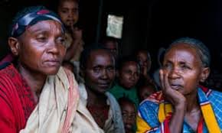
• How are the impacts of events and processes written about in a specific story different for women and for men?
• Where are the points of collaboration between genders? What are the common grounds and shared interests and needs? (Isis International-Manila and Mindanaw Women Writers 2007)
Finally, journalists should also explore more deeply the causes of violence against women during conflicts as well as the effects of women’s participation in peace negotiations in the security sector and in the executive, the legislature, and the judiciary. They should also investigate how states are implementing UN Resolution 1325 and how women and men are being impacted by the resolution. This gender-sensitive approach to peace journalism is necessary for sustainable peacebuilding and for advancing women’s rights and equality.

3.5 Personal safety of journalists

On December 18, 2013 the United Nations General Assembly (UNGA) adopted a resolution on the “Safety of Journalists and the Issue of Impunity.” The adoption of the resolution was in recognition of the consistent abuses journalists suffer—including threats, attacks, murders, and torture enforced disappearance, among others—and how such abuses negatively impact on the work of journalists and the value of journalism to society. The resolution went on to declare November 2 the International Day to End Impunity (IDEI) for crimes against journalists.
In Africa, the lead perpetrators of attacks on journalists have been security forces. Other perpetrators have included state or government officials (who are ordinarily supposed to be adherents of the law and protectors of press freedom), political party activists, fundamentalists, and other organized groups. Threats and actual attacks on journalists become more pronounced during conflicts, elections, political unrests, and crises situations such as during the Ebola epidemic in West Africa in 2014.
Also, Somalia, for example, has had a running conflict for over two decades now. Not surprisingly, it remains one of the most unsafe and, indeed, deadliest countries for journalists in the world. In the last five years alone, twenty-two journalists and media workers have been killed, according to records of the press freedom advocacy organization the Committee to Protect Journalists (CPJ 2015).

The above references to Somalia, Burundi, and Guinea are meant to illustrate how journalists’ safety is often affected by conflicts, political unrests, and national crisis situations. Unfortunately, crimes against journalists are often not investigated, with perpetrators often going unpunished, thereby fostering a culture of impunity.

The role of journalists remains critical in the promotion of democracy, good governance, and in fostering open and peaceful societies around the world. Attacks on journalists anywhere therefore constitute an assault on the very fundamental prerequisites for a society’s progress and development. This explains why the UNGA unanimously adopted the Resolution on the Safety of Journalists to ensure that UN member states prioritize the adoption and implementation of appropriate mechanisms for ensuring journalists’ safety and punishing crimes committed against them.
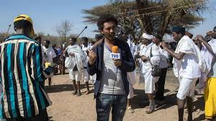
While the adoption of the UN resolution has boosted national, regional, and international efforts at combating crimes against journalists, there has been limited success so far. Attacks on journalists have remained high, particularly in conflict zones and in politically unstable environments. The situation calls for concerted efforts by all stakeholders—the UN, governments, civil society, academia, media professional groups, and journalists themselves to improve safety.

3.6 Personal safety tips
• Are you working on a sensitive topic?
• What is it, and why is it sensitive?
• Are you covering a high-risk location, activity or event? Describe the location, activity or event.
• Who will you be meeting? Are they potentially under surveillance, and might they be at risk if they talk to you?
• Is your security threatened by talking to specific people, visiting or working in a specific area?
• Circle or underline any of the following risks you may face: Abduction/kidnapping, violent and organized crime, abusive state security forces, corruption (bribery), riots/demonstrations, armed conflict, terrorist attack, road side bombs/IEDS/body traps, landmines and unexploded ordinance (UXO), low intensity warfare/guerrilla war, cultural hostility, petty crime/theft, carjacking, road accidents and other transport (aircraft, boat), crossing borders/checkpoints, political instability, outbreak of hostilities, death squads, militia, gangs, natural disaster (flood, earthquake), extreme weather, environmental hazards/toxins/poisons, physical and/or electronic surveillance, infectious diseases.
• Name and specify each risk and the measures you are taking to reduce the chance and severity.
• Consider if there is an increased risk as a result of your gender, age, ethnicity, religious beliefs or nationality and those accompanying you.

Exercise: write down the safety precautions that you take while covering conflict stories

3.7 Amplifying conflict sensitive reporting voices



Social media and immediacy of communication

The velocity of today’s communications often means a journalist’s ability to assess critically what is happening is reduced as is the possibility of maintaining a balanced distance from events, leading to a horrible (and potentially dangerous) cycle of misinformation.
Expressing observations and opinions in soundbites and tweets and avoiding rational discourse and analysis can fan conflict. It is increasingly difficult for organisations to hold back sensitive information from the public until an appropriate time.
The speed of communications and competition for audience share makes the media less likely to play a gatekeeper role by withholding certain information that could derail negotiations during sensitive peace negotiations. The accelerating speed of communications can have positive as well as negative consequences for conflict management. One positive example was the online mapping of violence and human rights abuses during the Kenya post-election violence in late 2007 and early 2008.
Kenya’s digital community responded with SMS and web technology creating Ushahidi, awebsite that collected and mapped reports of violence. These tools have the potential to play a key role in conflict prevention and early warning “to the extent that small-scale violence might presage larger-scale political violence.”

Again during the 2017 elections Ushahidi helped keep people safe, by informing them about the places to avoid – where there were riots or unrest. Another widely used platform was @Ma3Route (On Twitter), which shared information from citizens on which roads to avoid. Ushahidi’s mapping in the 2017 elections was not well publicised and went almost unnoticed, perhaps also because of the availability of information on social media platforms in general. It is likely that such tools have not yet lived up to their potential in part because there is a lack of focus regarding what to actually do with the data. Such data collection and mapping exercises may be too simplistic for the realities of the complex situations often found in fragile and conflict-prone states.25
Social media
Although, as has already been said, information derived from social media has to be treated circumspectly, it is nonetheless an essential tool of today’s journalism and can give you access to stories and images which would otherwise be very hard to reach. To use social media most effectively you will have to organise the chaos that is out there.
It is now common in developing news stories that those tweeting want to be heard so will use hashtags in the hope they will be picked up by anyone using a hashtag search.

Thanks to the development of the internet
- Social media might go round the restrictions of the mainstream and more traditional media.
- It is easier to tell stories using social media
- Social media can be used to amplify the need for peace and conflict resolution.

Discussion: What social media platforms are available in your country and how can you use them to tell your story

References

Adisa R. M. (2012). Conflict Sensitive Journalism And Newspaper Coverage Of Jos Conflict In Entrepreneurial Journal Of Management Sciences (Ejms). College of Management Sciences, Al-Hikmah University, Ilorin, Nigeria Volume 1, Number 1, 2012, Pages 174- 188.

Anstey, M. 2008. Managing Change: Negotiating Conflict. Cape Town: Juta.

Buromensky Mykhailo, Shturkhetsky Serhiy, Beals Emma, Kazanji Zoya, Betz Michelle, Schuepp Chris (2016) Conflict Sensitive Journalism: Best Practices And Recommendations. International Media Support (IMS).

Du Toit P. (2012). Conflict Sensitive Reporting A Toolbox For Journalists. Conflict Sensitive Journalism Project, Sol Plaatje Institute for Media Leadership, School of Journalism & Media Studies, Rhodes University, Grahamstown,

Fisher, R. (2000). Sources of Conflict and Methods of Conflict Resolution. International Peace and Conflict Resolution School of International Service. The American University.

Gadzekpo Audrey S. (ed) (2017) Conflict-Sensitive Coverage: A Manual for Journalists Reporting Conflict in West Africa. School of Information and Communication Studies, University of Ghana, Legon/African Peacebuilding Network (APN).

Haider, H., (2014). Conflict Sensitivity: Topic Guide. Birmingham, UK: GSDRC, University of Birmingham.

Howard R. (2004) Conflict sensitive journalism. International Media Support: Copenhagen

Media Council of Kenya (2016). The Anatomy of Conflict. A Conflict Analysis Handbook for Journalists: Towards Conflict Sensitive Reporting. Media Council of Kenya Nairobi

Rama E. K., Katja G. (2018) Philosophy and Practice. The Conflict-Sensitive Journalism Teaching Guide: Forum Civil Peace Service), Commission on Higher Education – Regional Office XI, PECOJON and the Media Educators of Mindanao, Inc.

Singh K. J. (2012) What are the different stages in a conflict? Retrieved from https://www.mbaofficial.com/mba-courses/human-resource-management/management-of-conflict/what-are-the-different-stages-in-a-conflict/

Umaru A. P., Sharafa D. (2017) The Media, Responsibility and Conflict-Sensitive Reporting in Nigeria in Emerging Trends in Gender, Health and Political Communications Emerging Trends in Gender, Health & Political Communication in Africa, Obiora F. Ike and Sunny E. Udeze, Rhyce, Kerex Publishers, Enugu Nigeria, ISBN:978-978-8506-23-2,

